Welcome to
Reception Class
2025 - 2026
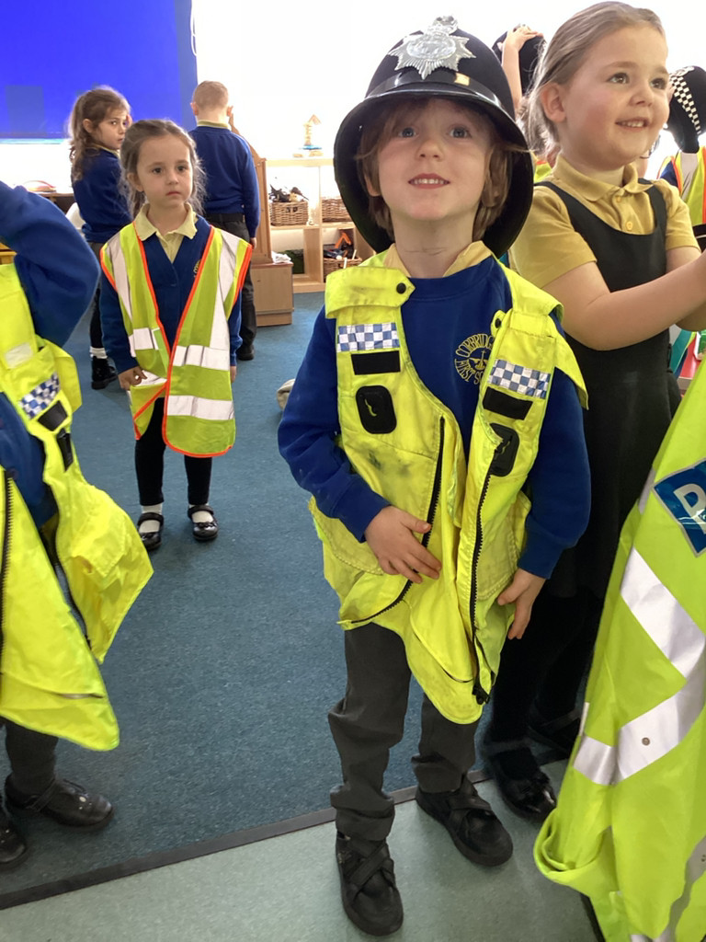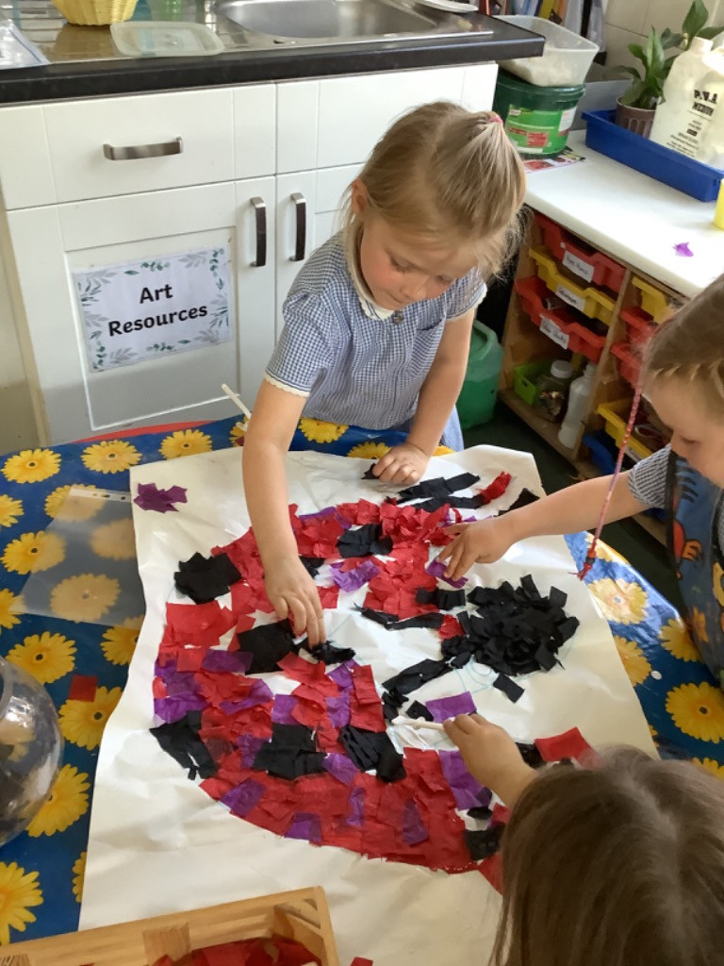
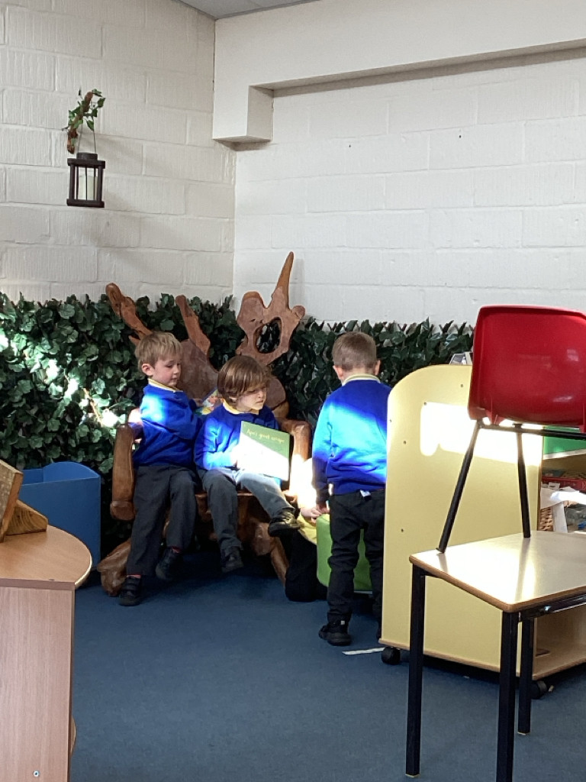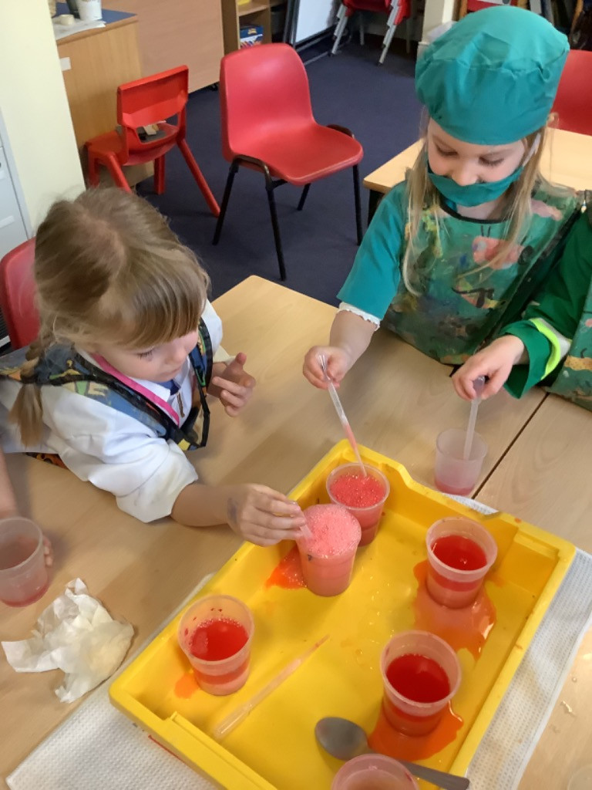

WELCOME
Corbridge Church of England First School is a small school with a big heart and a passion for its community. We all pride ourselves on acting with dignity and integrity. We speak the truth kindly and this makes us strong. We know every child personally and value them as individuals. We believe that every child is capable of great success and work hard with them every day to achieve their personal best. We empower them to be whatever they want to be and give them the self-confidence to know that they can achieve this. We are blessed with a team of dedicated staff who are committed to providing the very best for our children.
With God’s guidance we all strive every day to be
‘The best that we can be’.
We hope that both you and your child will enjoy being a special part of the Corbridge First School family as we embark on their exciting Reception year.
Mrs S Hart
Head Teacher
All staff are always happy to help and if you have any worries, problems or even good news for us… please get in touch.

Reception – Corbridge CE First School

SCHOOL CONTACT DETAILS
Address Corbridge C of E First School St Helen’s Lane
Corbridge
Northumberland
NE45 5JQ
Telephone 01434 632534
Email admin@corbridgefirst.northumberland.sch.uk Website www.corbridgefirst.northumberland.sch.uk
Office Mrs Steele or Miss Ruddick
Reception – Corbridge CE First School

THE FOUNDATION STAGE CURRICULUM
The Foundation Stage Curriculum is divided into two areas, Prime and Specific:
The prime areas of learning: 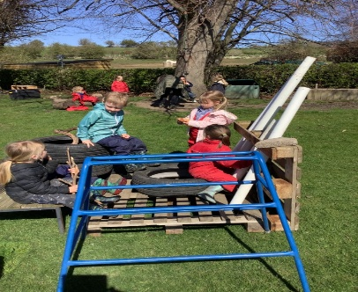
• Communication and
Language
• Physical Development
• Personal, Social and
Emotional Development
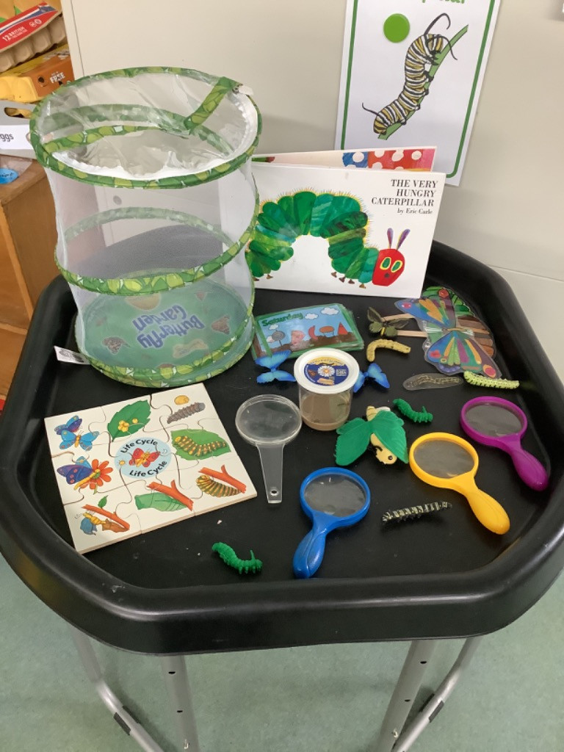
The specific areas of learning:
• Literacy
• Mathematics
• Understanding the World
• Expressive Arts and Design
High quality learning opportunities foster children’s independence, co-operation and language skills through problem solving both indoors and out.
Reception – Corbridge CE First School
A DAY IN RECEPTION
8:40-8:45am | Teachers will open the doors to welcome the children in and can answer any questions that you may have.
8:45-8:50am | The children will join in with registration, a welcome song and look through the daily timetable and special events.
If children are late and the gates are locked parents must take the children to the office to ensure they have a mark in the register. Office staff will bring the children down to the classroom.
8:50am | Phonics- children will begin following the Read, Write Inc phonic programme which is taught throughout school.
9:35 | Literacy- Using a key text as a learning stimulus the morning sessions consist of a range of whole class teaching, group activities, one to one teaching and child-initiated learning. We have indoor and outdoor provision and the children have many opportunities to flourish.


Snack Time | Fruit is provided for the children free of charge in Reception Class. Snack is shared together during story time and Special Person celebration.  Milk is available – the cost and order forms are made available to parents/carers at the start of each new term.
Water | All children should bring a labelled water bottle to school so they can access water throughout the day in their own clean bottle. Children must not bring juice.

Reception – Corbridge CE First School
A DAY IN RECEPTION
11:50  Lunch   | The children eat as a class in the school hall. They then return to the EYFS garden area to access outdoor play. During the Summer Term, the children are given the opportunity to play with children from other year groups on the main school yard.  Currently, all children in Reception, Year 1 and Year 2 are eligible for a free school lunch irrespective of parental income. Our cook provides excellent nutritious lunches every day and we hope that you and your child choose this option. If your child brings a packed lunch to school, please ensure it provides them with a healthy balanced lunch. We are a NUT FREE zone so please support us by ensuring your child’s packed lunch or snacks are ‘nut free’.
1:00pm  Afternoon | The children join in with a Peer Massage session to settle and relax ready for the afternoon’s learning. The afternoon sessions consist of plan, do, review (child-initiated learning) using both the indoor and outdoor environments. Activities based on the learning topic will also be initiated. Daily large group activities also take place as well as a weekly PE session.
3:15pm | Children are dismissed by the Reception Class side door (with the ramp access) at the end of the day, 1:1. Children are only ever released to an agreed with adult as shared by you on the going home arrangement forms.  At the start of term, we may  begin this slightly earlier as it takes us a while to develop our routine and become familiar with family faces.


Reception – Corbridge CE First School
All families will be asked to complete and return the “Going Home Arrangements” form. This will show vital information including adults who can collect the children. If there is ever a change in information or routines we ask that you keep staff informed to avoid any confusion.

OUTDOOR PLAY
Our outside area is planned to be an extension of the 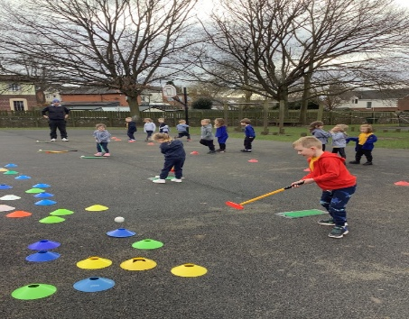
classroom. Opportunities are provided to promote
stimulating learning and develop life-long skills
including teamwork and communication.
Various skills including teamwork, problem solving and communication are nurtured in the outdoor environment. Writing, reading and number skills are encouraged and well planned for through our outdoor provision. 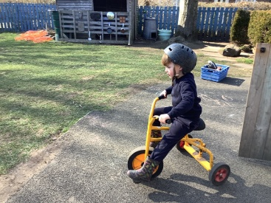
Children are naturally active. To keep fit and healthy they need plenty of fresh air and active play. When children play outside, they:
• Enjoy using their seemingly inexhaustible reserves of energy • Develop muscle control and coordination
• Learn to negotiate obstacles and become aware of space • Practice skills such as skipping, throwing and catching
• Use all their senses to enjoy the different seasons
• Experience playing with larger toys and materials
• Find out about their environment by exploring, observing and recording what they discover.
Reception – Corbridge CE First School

You can help prepare your child for outdoor play by making sure that they can put on their wellies and manage some of the fastenings. In hot weather, please don’t forget to apply your child’s sun cream before they come into school and ensure they have a named sunhat.
READING AND HOME HELP
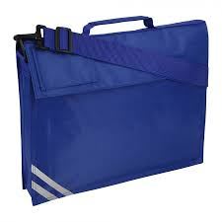
When your child starts in Reception Class they will
need a book bag which they need to bring to school
every day. We ask parents to check the bag each
night, when they read with their child, for any letters,
information or home tasks and activities.
Your child will receive a reading book within the first few weeks of school. They may begin their reading journey with a picture book without words. By encouraging your child to tell the story using the pictures, we help them to learn that there are a range of strategies available to help them read. It also gives them the opportunity to develop story telling language and use their own creative ideas which assists them greatly in their writing. Soon after, your child will be given a staged reading book which gives them the opportunity to apply their phonic skills and simple key word recognition.
As well as their reading book, the children will be given the opportunity to choose a book from the EYFS library to share with you at home. Bedtime reading plays a very important part in the children learning to read.
Your child will be given a reading diary. Staff will read with your child individually at least once a week. They will also read in guided reading groups and with shared texts most days. The reading diaries have five
Reception – Corbridge CE First School
spaces and we ask that a family member records each day (Monday – Friday) that they have read with their child. By sharing the books and practising key words daily the children can make the best possible progress.

SCHOOL UNIFORM
Our children look very smart in their school uniform. It helps them to feel a part of our school community and emphasises that we are part of a whole team. It is also practical enough for everyday wear.
• A blue sweatshirt or cardigan (available with the logo but not essential) • A gold polo shirt
• Grey skirt, pinafore dress / trousers or shorts
• A blue checked dress in the summer
• Practical black flat shoes or black trainers.
(Sling back, mules, heeled shoes are not safe for the children in school.)
PE Kit
• Gold T-shirt
• Blue shorts
• Plimsolls
All clothing needs to be clearly marked with your child’s name. We find that the iron-on labels tend to come off quite easily, so if possible please use a marker pen and write directly on the size label or use sew on labels instead. Children will still occasionally come home with other children’s sweatshirts or no sweatshirt at all, but we can track down missing clothes more easily when they are named.
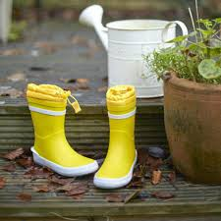
Wellington Boots
We go outside every day and in all kinds of weather, so please make sure in addition to a suitable coat your child has named wellies which can remain in school.
Reception – Corbridge CE First School
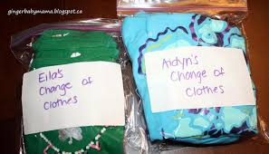Accidents of any kind may occur where your child may need to be changed throughout the day. Please ensure that your child has a spare set of clothes/ underwear/ socks available each day. They may stay on their peg or be brought in daily. Please return a fresh set as soon as possible.
Where school clothing is borrowed, please wash and return it to school.
Reception – Corbridge CE First School

