PSED (Personal, Social and Emotional Development)
- Daily ‘super powers’ Special Person linked to our Christian values
- Snack times / daily circle times
- PSHE stories, songs and videos
- Independence in toileting, handwashing, changing wellies, fastening own coats and taking responsibility for their belongings
- Continuing to follow our class rules, routines and expectations
- Continue to engage in co-operative play and turn taking games
C&L (Communication and Language)
- Daily story time
- Pin up superhero cape for super vocabulary
- Practise listening attentively and respond to what they hear with relevant comments including asking questions during news time
- Encourage speaking in full sentences using the correct tense
- Talk about different characters in stories and make simple predictions
- Role play stories using puppets and or costumes and props
- Superhero rescue centre role play

EYFS Curriculum
Superheroes/ People who help us
Spring 1 2026

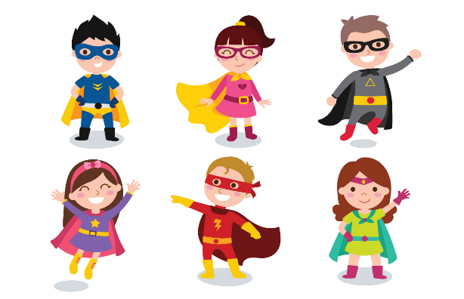

PD (Physical Development)
Gross Motor
- Daily outside play on large equipment
- Superhero obstacle course
- Superhero movement games
- Bikes & scooters
- Running track
- Weekly PE Lessons with Mr Thompson
Fine Motor: Pinching, tweezing and twisting/ Cutting and spreading
- Play-dough / gloop
- Using one handed tools such as scissors, paint brushes, glue sticks and tweezers
- Threading beads, weaving with pipe cleaners and wool
- Construction area -make a superhero den
- Mark making and colour mixing

Don’t forget …
- A spare change of clothes, labelled, to stay in school
- Check all clothes are labelled
- Named wellies to stay in school
- Water bottles sent into school daily
- Regular Tapestry updates from school – feel free to add your own messages and photos and we will share in News time.
- Check your parentmail account regularly
- Visit our school website for further information www.corbridgefirst.northumberland.sch.uk
- We will also tweet on Twitter - @CorbridgeFirst

UW (Understanding the World)
- Daily worship and prayer time
- Weekly Jack in the Box worship
- Weekly RE lessons: Being Special: Where do we belong? (Salvation)
- Real life super heroes ‘People who help us’ – jobs and roles
- Science fortnight – STEM experiments e.g. frozen superheroes, magnet flying superheroes.
- Positive attitudes towards differences
- Seasonal changes

Mathematics
Following White Rose Maths, we will cover the topics in our daily group sessions:
- Triangles and circles
- Shapes with 4 sides
- Alive in 5
- Mass and capacity
- Growing 6,7 and 8

Other daily maths opportunities:
- Share date (Days of the week song), timetable, how many present
- Daily counting opportunities
- Counting forward and backwards from any number to 20
- Number songs and rhymes
- Measuring ingredients
- Maths provision
Expressive arts and design
- Design and make their own superhero vegetable, mask, cape and costume, selecting the materials they will use
- Talk about the process of making and how they could improve.
- Painting and printing with different media
- Begin to add detail to their superhero drawing in following a simple step to step instructions
- Weekly music sessions with Mr. Reed
- Movement and dancing to music.
- Perform superhero songs and rhymes using actions
- Superhero Rescue Centre role play
Literacy
Core Texts: ‘Superworm’ and ‘Supertato’
Non- Fiction ’People who help us’ texts

Daily Read Write Inc. Phonics Groups:
- To read and write set 1 sounds including special friends sh, ch, th, qu, ng and nk
- To read and write CVC words containing the sounds they know e.g. cat, mop, pin, chat, shop
- To recognise and write red tricky words I, the, my, said, you, of, are, be and no.
- Individual and small group reading
Literacy in the classroom:
- Daily whole class and group stories
- Weekly adult directed tasks such as ‘Drawing Club’, practising forming letters correctly, using the correct pencil grip and sounding out to spell simple words.
- Access to literacy resources in provision.

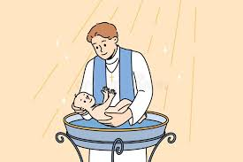
Visit:
St Andrew’s Church
to learn about Baptism

Help at home by …
- Support your child with their Reading Book at home
- Practise reading and writing sounds from their Green Sound Book they have learnt in a variety of contexts e.g. with pens, chalk, in sand, outdoor materials, magnetic letters
- Learn to read and write red tricky words I, the, my, said, you, of, are, be and no.
- Encourage everyday Maths – measuring when baking/cooking, playing board games/dominoes, sorting objects, sharing out items, using money, shape and number hunts.

