C&L (Communication and Language)
- Daily story time
- Practise listening attentively and respond to what they hear with relevant comments
- Encourage speaking in full sentences using the correct tense.
- Talk about different characters in stories and make simple predictions.
- Role play stories using puppets and or costumes and props
- Fairytale Shop or castle
PSED (Personal, Social and Emotional Development)
- Daily Special Person linked to our Christian values/ prayer times
- Snack times / daily circle times
- Sorting healthy and unhealthy food from Red Riding Hood’s basket
- PSHE stories, songs, videos
- Independence in toileting, handwashing, changing wellies, fastening own coats and taking responsibility for their belongings
- Continue to follow our class rules, routines and expectations
- Continue to engage in co-operative play
EYFS Curriculum
Traditional Tales
Spring 2 2026
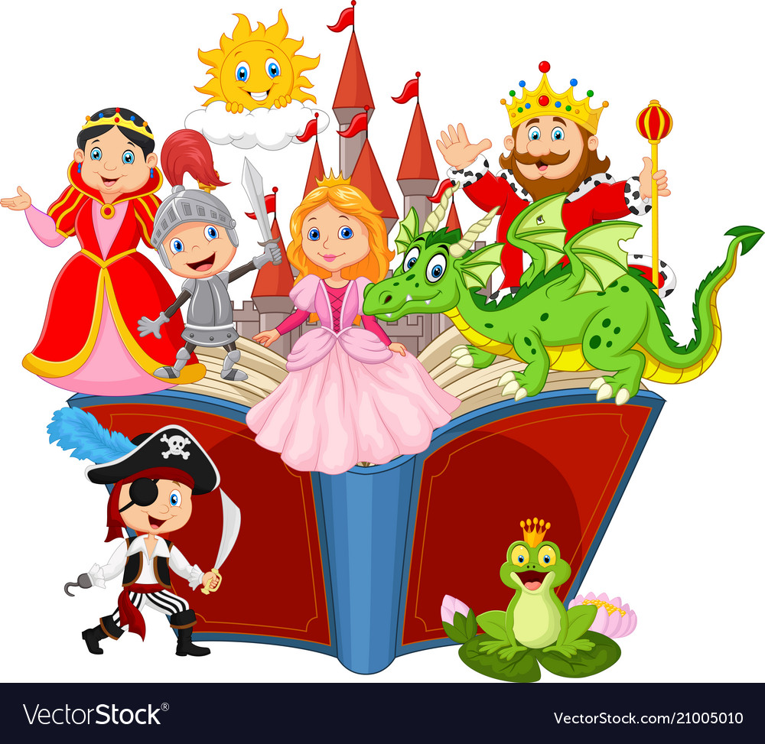

UW (Understanding the World)
- Christian values/ Prayers
- Weekly Jack in the Box worship
- Weekly RE lessons: Salvation/ Easter celebrations
- Making and following simple maps (e.g. to get to Grandma’s house).
- Comparing past and present, looking at characters, settings and events in stories
- Talk about seasonal changes of springtime
- Weekly Forest School sessions
- Explore celebrations from different cultures e.g. Chinese New Year
- Growing beanstalks!

PD (Physical Development)
Gross Motor
- Weekly golf lessons from a specialist coach
- Daily outside play on large equipment
- Bikes & scooters
- Running track
- Weekly PE Lessons with Mr Thompson
- Weekly forest school sessions
Fine Motor: Pinching, tweezing and twisting, cutting and spreading
- Play-dough / gloop
- Using one handed tools
- Threading beads, weaving with pipe cleaners and wool
- Construction area – building the houses from ‘The Three Little Pigs’
- Mark making and colour mixing
Don’t forget …
- A spare change of clothes, labelled, to stay in school
- Check all clothes are labelled
- Named wellies to stay in school
- Water bottles sent into school daily
- Regular Tapestry updates from school – feel free to add your own messages and photos and we will share in News time.
- Check your parentmail account regularly
- Visit our school website for further information www.corbridgefirst.northumberland.sch.uk
- PE kits to be worn both on Tuesdays and Thursdays this half term

Expressive arts and design

- Make fairytale masks for role play
- Design and make fairytale sock puppets inspired by the artist Paul Klee
- Design and make the ‘Three Little Pigs’ Houses
- Retelling and performing traditional tales using props.
- Painting and printing with different media
- Weekly music sessions with Mr. Reed
- Movement and dancing to music

Parents/Carers invited into school on Wednesday 25th March at 1.30pm for the Spring Music Concert.

Literacy
Core Texts: ‘Little Red Riding Hood’
‘The Gingerbread Man’
‘The Three Little Pigs’
and
‘Jack and the Beanstalk’
Daily Read Write Inc. Phonics Groups:
- To read and write set 1 and some set 2 sounds including special friends sh, ch, th, qu, ng, nk, ee, igh, oo, ay etc
- To read and write words containing the sounds they and begin to write simple sentences
- To recognise and write red tricky words I, the, my, said, you, of, are, be and no
- Individual and small group reading
Literacy in the classroom:
- Daily whole class and group stories
- Weekly adult directed tasks such as ‘Drawing Club’, practising forming letters correctly, using the correct pencil grip and sounding out to spell simple words
- Access to literacy resources in provision

Mathematics

Following White Rose Maths, we will cover the topics in our daily group sessions:
- Length, Height and Time
- Building 9 and 10
- Explore 3D Shapes

Other daily maths opportunities:
- Share date (Days of the week song), timetable, how many present
- Daily counting opportunities
- Counting forward and backwards from any number to 20
- Number songs and rhymes
- Measuring ingredients
- Maths provision in the areas

Help at home by …
- Support your child with their Reading Book at home, record in diary and return to school each Wednesday
- Share a library book each week and return by Friday to check out a new one
- Practise reading and writing sounds from their Green Sound Book and new Set 2 sounds. Write words containing the sounds they know.
- Learn to read and write red tricky words I, the, my, said, you, of, are, be and no (Tricky word keyrings)
- Encourage everyday Maths – measuring when baking/cooking, playing board games/dominoes, sorting objects, sharing out items, using money, shape and number hunts.

