Daily Learning activities
Tuesday 12.1.21

Hi everyone, I hope you are all well.
Please could you like the post I have attached this home learning document on. This means that even if you do not get a chance to send me a comment, photo of video I can see how many children are accessing their online home learning. This will be especially useful when Tapestry is having issues because I know that yesterday it was difficult to send me photos and videos. If you could continue to do this every day, it would be greatly appreciated. There is a new maths and literacy activity for today. I have also uploaded my phonics video- bouncing and stretching sounds- again just in case you missed it yesterday. I am bouncing and stretching the set 1 sounds which is what we do at the beginning of each phonics session in school. I would love to see some videos of your child bouncing and stretching the sounds at home! There is also a new phonics video to show your child today. Please choose one activity from the Topic grid to complete today (I have attached the grid again- just in case you missed it yesterday).
Today’s activities are:
Phonics
Bouncing and stretching phase 1 sounds with Miss Jewitt.
After bouncing and stretching the sounds please play our phonics video for today- ch sound.
Literacy
This week our literacy challenges are based on the story, ‘Tyrannosaurus Drip’ by Julia Donaldson.
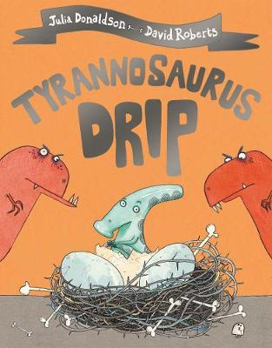
Tuesday – Favourite Character
Listen to the story again. Who is your favourite character? Why?
Draw your favourite character. You could use pens, colouring pencils, crayons or paints. Can you write your favourite characters name?
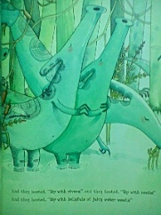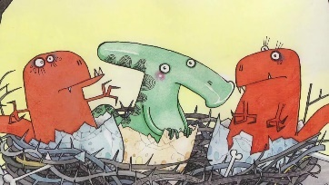
Maths
This week the children will talk about night and day and order key events in their daily routines. They will use language to describe when events happen e.g. day, night, morning, afternoon, before, after, today, tomorrow.
Children begin to measure time in simple ways e.g. counting the number of sleeps to an important event or using timers to measure durations of events.
Tuesday- Active Maths
Label 2 areas in your home ‘daytime’ and night time’. Call out an activity and your child runs to the day time or night time area. For example, stars appear, we put on pyjamas, we get dressed, foxes come out, we eat lunch, owls hunt etc. Encourage the children to suggest some of their own night and day activites.
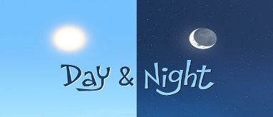
This Photo by Unknown Author is licensed under CC BY-SA-NC

I hope you enjoy today’s activities! Don’t forget to keep in touch on tapestry by letting me know which activities you have enjoyed. Although home learning is important it is also important that your child enjoys daily fresh air and exercise- so wrap up warm and enjoy being outside!
Take care everyone,
Miss Jewitt

