Reception

**Secondary Curriculum Driver: CL (Communication and Language)**

**Intended outcome:**

Children can listen to stories with increasing attention and recall.

Listens and responds to ideas expressed by others in conversation or discussion

Children are beginning to understand ‘why’ and ‘how’ questions.

Uses language to imagine and recreate roles and experiences in play situations.

Introduces a storyline or narrative into their play.

**Proposed learning opportunities:**

Listen to and ask questions about their friends’ homes and interests.

Begin to explore kindness, celebrating others, differences and uniqueness through daily Special Person time.

Engage in imaginative play, recreating familiar ‘home life’ scenarios. Be able to communicate own needs and interests in appropriate ways.

**Primary Curriculum Driver: PSED (Personal, Social and Emotional Development)**

**Intended outcome:**

Children can play in a group, extending and elaborating play ideas, e.g. building up a role-play activity with other children.

Children can explain their own knowledge and understanding, and asks appropriate questions of others.

Children are able to listen to others’ ideas and take in to account what other people say.

Children are confident to talk to others when playing, and will communicate freely about own home and community.

Children can talk about themselves in positive terms and talk about abilities.

**Proposed learning opportunities:**

Circle time sessions finding out about our class friends, their homes, families, pets, hobbies etc.

Small group time activities, to promote speaking and listening using ‘The Everywhere Bear’ summer activity books initially as stimulus, moving on to our families and pets.

Seasonal display of items of interest relating to the season or topic, to generate discussions between the children.

Children to become settled and accustomed to the class members, routines and expectations.

Autumn 1

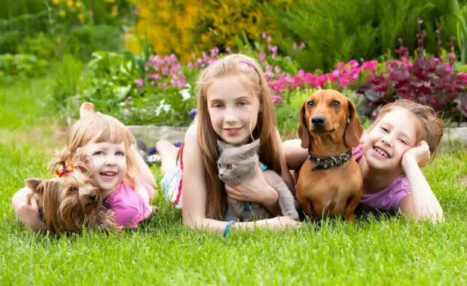



**Mathematic Development:**

**Proposed learning opportunities:**

We follow White Rose Maths scheme in Reception and throughout school.

During this term we will be exploring;

* Matching and sorting
* Comparing amounts
* Representing, comparing and composing numbers
* One more and one less
* Comparing size, mass and capacity
* Positional language
* Shapes with 4 sides

**Physical Development:**

**Proposed opportunities:**

Large scale activities such as outdoor play, bikes, scooters and those relating to developing early writing.

Develop and strengthen hand muscles through Dough Disco and Funky Finger activities.

Use various tools and equipment.

Begin to form letters correctly.

Begin to move in response to music.

**Understanding World:**

**Proposed opportunities:**

Understanding rules for school and the reasons why we have them.

Begin to know the different type of pets people may have. Understand how we can care for a pet.

Learn about simple responsibilities which come from owning a pet.

**Literacy:**

**Proposed learning opportunities:**

Recognise and write own name.

Set 1 RWI Speed Sounds- hear, recognise and suggest words beginning with each sound.

Begin to hear and continue rhyming strings.

Predict endings to stories and talk about characters.

Understand that stories have a beginning, middle and end.