Topic challenges  Week beginning 1.2.21  This week our topic challenges are based on the story, ‘Zog and the flying doctors’ by Julia Donaldson.  You can begin by listening to the story. We’ve suggested these follow up activities to consolidate a range of reading, writing and creative skills previously taught in school.  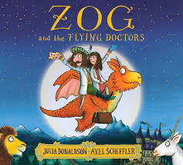 | Edible Castles  Can you make your own yummy castle for lunch today?  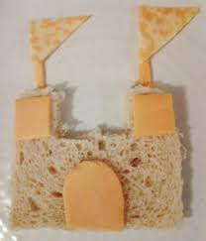 | A cure for yellow fever  According to the book, the cure for “orange fever” requires a grated unicorn horn, a lion’s sneeze, mermaid scales, slime and cheese. Can you use basic household items to conjure up your own ‘cure’ for yellow fever? Be as creative as you can using what you have in the house!  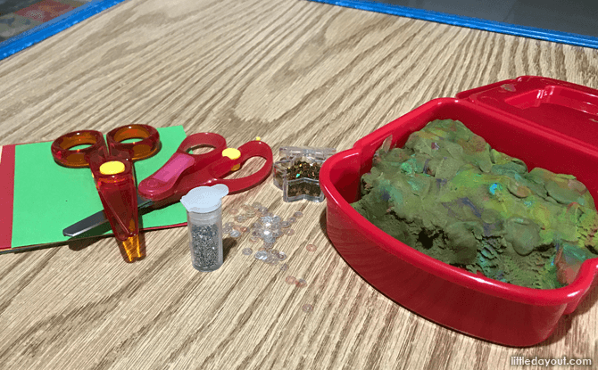  You could use: Grated unicorn horn- shredded coloured paper, lions sneeze- glitter, mermaid scales- sequins, slime- playdough, cheese- gold stars.
RE-Infant baptism and dedication  Watch the following short video clips about baptism.  A Christian baptism (pt 1/2) - KS1 Religious Education - BBC Bitesize  A Christian baptism (pt 2/2) - KS1 Religious Education - BBC Bitesize  Design a baptism invitation for a friend. Make it look bright and colourful. | Doctor Role Play  In the story Zog and the flying doctors help people to feel better. Can you create a toy hospital and act out being a doctor? Perhaps your toy needs a plaster or bandage (you could use toilet roll). What could you do to cheer them up when they are ill- read them a story? Make them a snack? Make them a card? You might decide you need a doctors bag- what would you put inside?  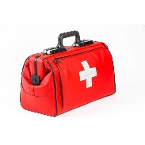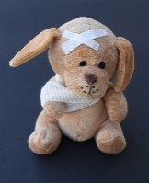 | Computing- Algorithms  Watch the song ‘Algorithm Al’, https://youtu.be/cvk5vIgZAZw  Discuss the song and highlight that an algorithm is a set of instructions that humans and computers follow, to complete tasks. Just like telling a story in the correct order, instructions need to be in the right order, or they don’t make sense. Write your child’s name in large letters on a piece of paper and cut them into separate letters. Place them in the wrong order. Discuss if this is correct. Encourage your child to place the letters in the correct order, to spell their name.

