Literacy challenges  Week beginning 25.1.21  This week our literacy challenges are based on the story, ‘Zog’ by Julia Donaldson.  You can begin by listening to or watching the story (it is on BBC iplayer.)  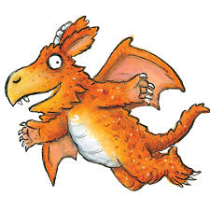 | Monday-Design and label your own dragon  Zog and his friends are all dragons, but they all look different. Can you draw your own dragon? What colour will it be? It is a big or a small dragon?  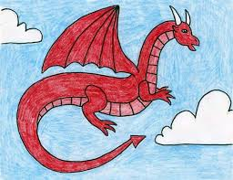 | Tuesday – Teriffic Tuesday  Zog goes to dragon school to learn how to be a dragon, just like you go to school. He wins a golden star for trying so hard and being the first dragon to capture a princess.  Can you think of a time you tried so hard to do something and you were proud of your hard work?  On the star template, maybe you could draw something that you or someone in your family has done which was so clever, kind or special. Why do they/ or you deserve a golden star?  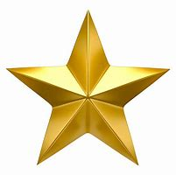
Write it Wednesday  My Dragon description. Using your dragon drawing from Monday we are going to find out some more information about your dragon. What does your dragon like? What does it eat and drink? I wonder what special skills your dragon will have?  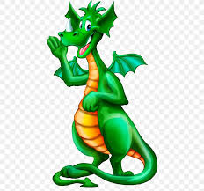 | Thursday – Thinking about characters speech  What do you think Zog might be saying here? How is he feeling?  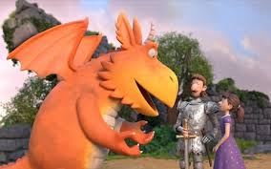 | Friday – Brave Knights  Can you use the internet of information books to help you find out some information about knights?  Maybe you could share your favourite fact with me?  