Topic challenges  Week beginning 29.6.20  This week our topic challenges are based on the story, ‘Oliver’s Vegetables’ by Vivian French.  You can begin by listening to the story. We’ve suggested these follow up activities to consolidate a range of reading, writing and creative skills previously taught in school. | Monday – Science Grow your own carrot  Can you grow a carrot top in water?  How long will it take?  What does the carrot need?  What do you notice?  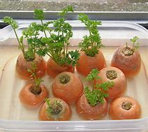  Instruction sheet attached. | Tuesday – Categorise the fruit and vegetables  Can you sort the pictures into categories. How will you sort them?  - Color  - Shape  - Fruit/vegetables  - Where they grow  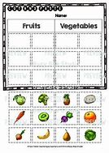
Wednesday –make own garden  Can you make your own pretend vegetable garden?  You could use play doh.  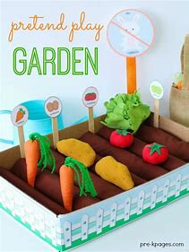 | Thursday – Vegetable basket  Can you make a basket full of your favourite vegetables?  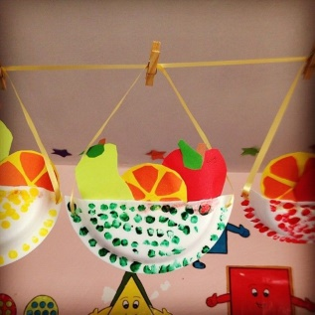 | Friday- Heaviest vegetable  Can you find the heaviest/lightest vegetables in your house?  