Make the Rules!

Princess Mirror Belle loves to splash water all over her bathroom floor- her mummy even tells her to do it!
We have rules to keep us safe and healthy, but imagine how much fun it would be if sometimes we could change them a little!
Here are some new rules I would make:

- Always have chocolate BEFORE dinner!
- Baths MUST have glitter or slime in. 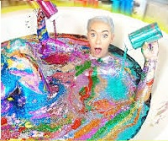

Can you think of some more new rules?

