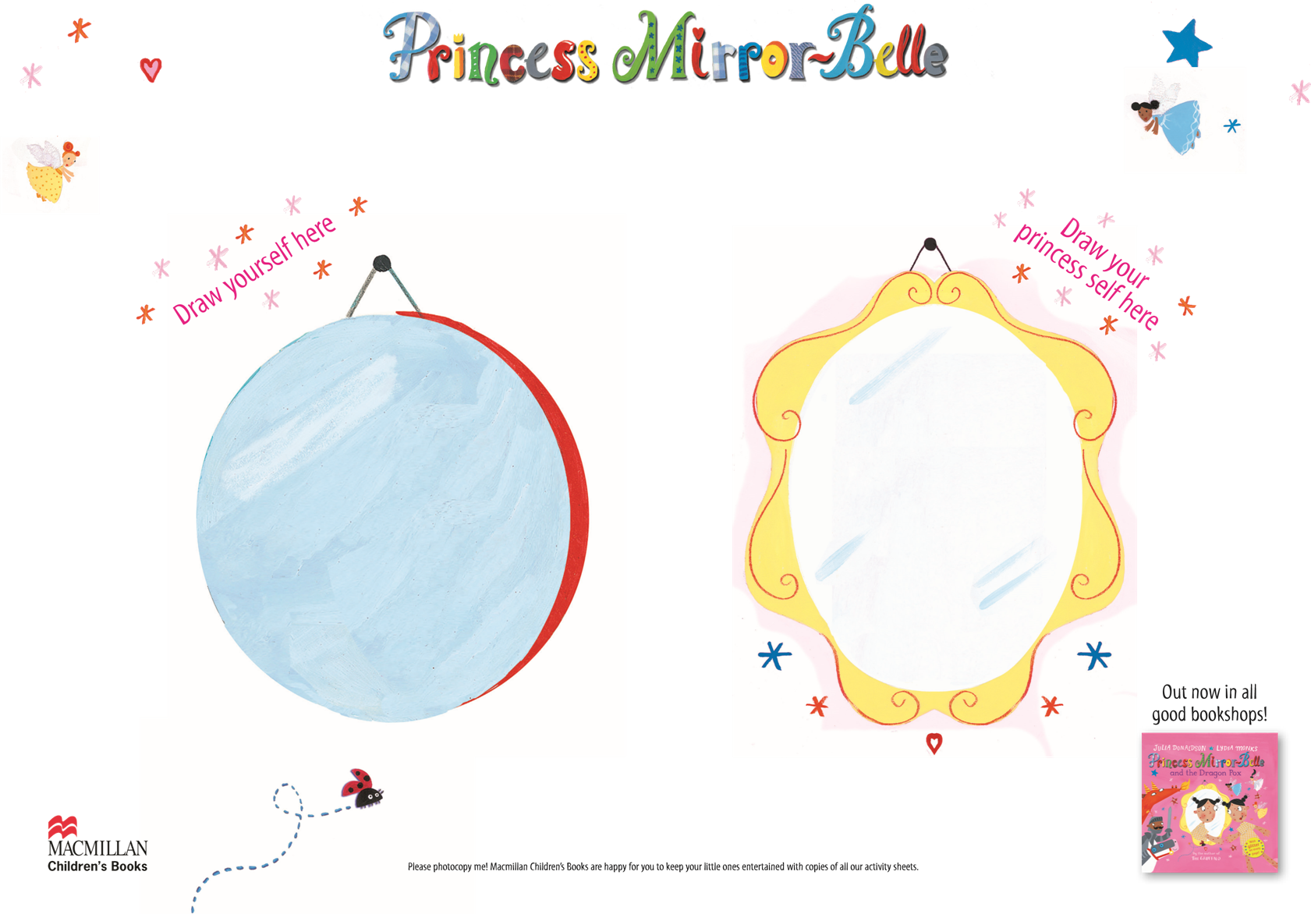

In the story, Ellen meets her Princess mirror-self. Imagine you had a mirror self, would they look the same as you?