Literacy challenges  Week beginning 22.6.20  This week our literacy challenges are based on the story, ‘Zog’ by Julia Donaldson.  You can begin by listening to or watching the story (it is on iplayer.) We’ve suggested these follow up activities to consolidate a range of reading and writing skills previously taught in school.  https://youtu.be/9_LmS3q4E6k  https://www.bbc.co.uk/programmes/b0bwdw8y  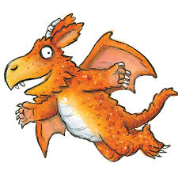 | Monday – Design and label your own dragon  Zog and his friends are all dragons, but they all look different. Can you draw your own dragon? What colour will it be? It is a big or a small dragon?  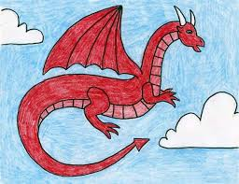 | Tuesday – Wizarding words! Join phonics and literacy together  Zog goes to dragon school to learn how to be a dragon, just like you go to school.  Can you think of (and write) a rhyming string of ‘og’ words? Og, Zog, dog etc.  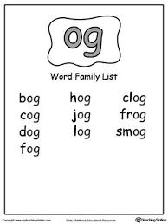
Write it Wednesday  My Dragon description. Using your dragon drawing from Monday we are going to find out some more information about your dragon. I wonder what special skills your dragon will have?  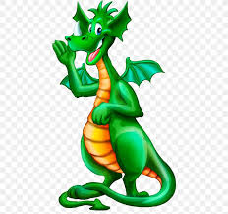 | Thursday – Speech bubble  What do you think Zog might be saying here? Use your phonics to help you.  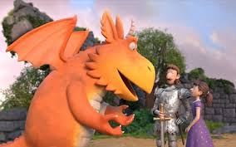 | Friday – Brave Knights  Can you use the internet of information books to help you find out some information about knights?  Maybe you could write down your favourite facts?  