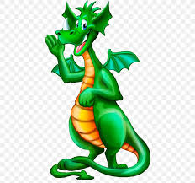



Dragon description

What does your dragon look like?

Where does it live?

What does it like to eat?

What special skills does it have?