Wanted!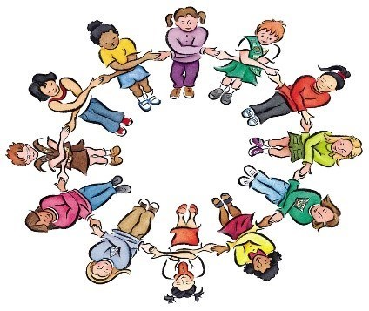 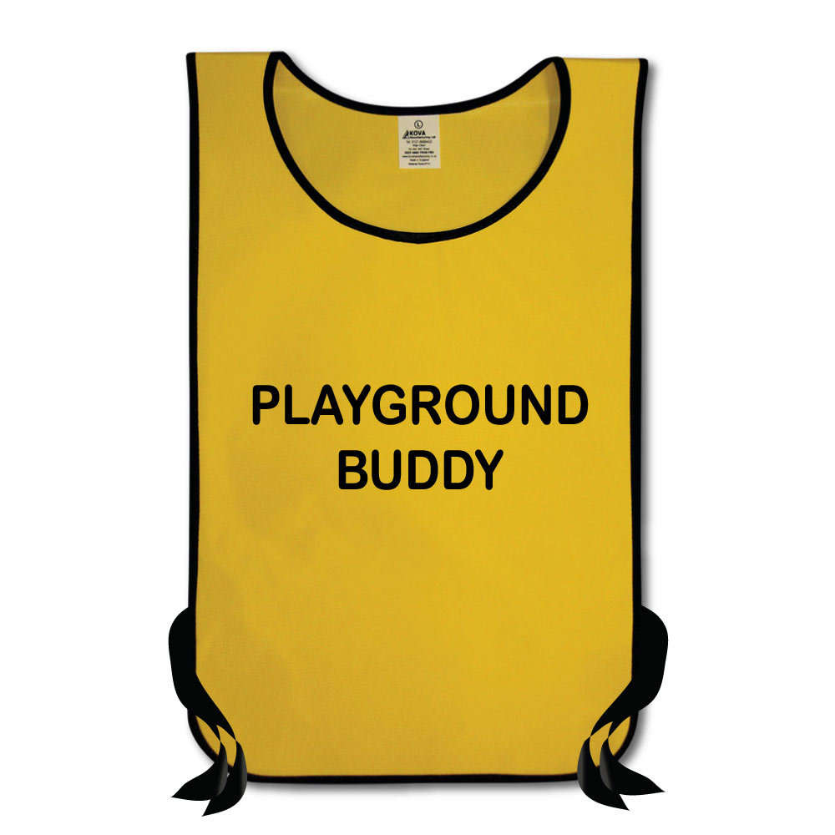

Class/PLAYGROUND BUDDIES
If you are 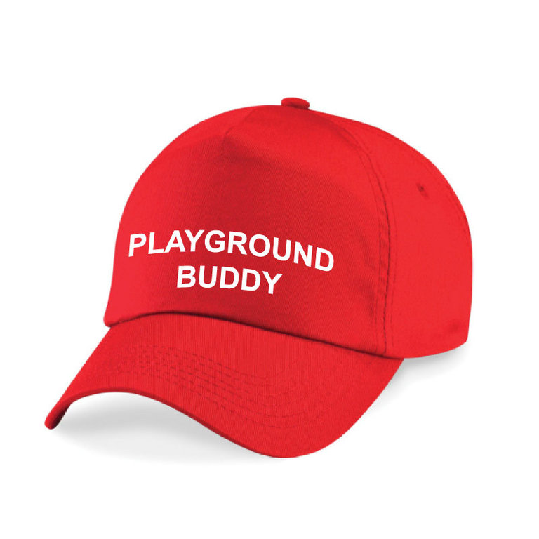

- Friendly
- Sensible
- Patient
- A good listener
- Able to help promote the calm
school code at break and
lunchtimes

Then we need YOU!

Please apply in writing
Job description

Title: Class/Playground Buddy

Hours: Play and lunchtime (and some other times throughout the day as and when neccassary)

What you need to know:

Calm School Code
How to encourage & set a good example
Playground games & how to start them with a group
How to spot children that are alone, and encourage them to be friends with
others
How to watch out for bullying and report it to the right adult
How to talk sensibly to adults in school if you need to.

As a person, you need to be:
Proud of your school
Friendly
Patient
A good listener
Sensible
Able to get on well with your adults in school as well as with your friends
Good at thinking of playground games and willing to learn new ones.

If you wish to apply:

Write a letter to the school council, explaining why you would
be good at this job. It’s a good idea to give examples. One idea might be: ‘My
favourite playground games are…’

