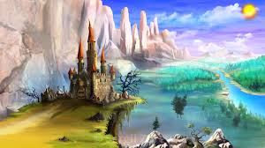
My castle

Princess Mirror Belle lives in a castle with her mummy and daddy the King and Queen.
Can you draw a picture of a castle you would love to live in? Would it have any special rooms?

