Literacy challenges  Week beginning 18.1.21  Our key story this week is ‘Harry and the Bucketful of Dinosaurs.’  There are no attachments for these activities, as the main focus is developing imagination, linking ideas to the text, understanding what they have heard in the story and supporting speech and language development. | 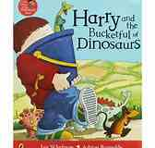 | Harry loves his dinosaurs and likes to carry them around in his bucket so that they can go places together.  Do you have any favourite toys?  What would you put in your bucket?  Tell you grown up or ask them to draw a bucket so that you can draw your favourite toys inside.  .
Speaking task  Imagine Harry has brought his bucketful of dinosaurs into Nursery to play for the day.  Can you think of things you would tell Harry and the dinosaurs about our Nursery days?  You could mention Special Person  Snack time  The areas in our room and garden  Your favourite place to play  All of our nursery friends | Favourite toy  Do you have a favourite toy?  Could you draw a picture of it and use words to describe why you like it?  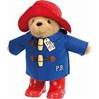 | Where would you go?  Think about the toys you chose to go in your bucket.  Imagine you could go anywhere in the world with them? Where would you go?  Would you go somewhere hot or somewhere cold? Would you stay near home and go to your favourite place?  What is it like there? What can you do?  Who will you see there and what will you need to take with you?  Maybe you could tell me where you would visit and why?

