**Nursery**

**Spring 1**

**Nursery Rhymes**

**CL (Communication and Language)**

Listen to and identify rhyming words.

Hear and continue a rhyming string.

Listen to particular sounds in the environment, go on a listening walk indoors and outdoors.

How do you feel Humpty felt after his fall? Can we fix him? Explore materials to see if we can design protective clothing for our eggs, then test them out by pushing them off a small wall.

Miss Polly had a dolly who was poorly, who looks after us when we are poorly. Explore caring for others in the Doctors Surgery Role Play.

**Understanding the World**

To learn a range of different traditional nursery rhymes and where they originated from.

To look for spiders in the drain pipes and around the outdoor setting.

To notice the weather and think about the rhymes associated with it.

To explore eggs and how strong they can be or how we can keep them safe; hard boiling and exploring materials.

Explore floating and sinking, e.g., with rubber ducks- 5 Little Ducks.

Where does wool come from?

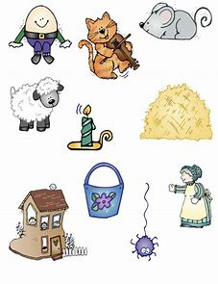

**Physical Development:**

The children will engage with daily physical development through large outdoor play (using the garden, running track, allotment, bikes and equipment) and also through focused adult directed sessions.

We are continuing our ‘Squiggle While You Wiggle’ fine motor pre-writing programme too, which we were really enjoying.

March like the Grand Old Duke

Make a boat and row.

Make jam tarts- Queen of Hearts.

**Help at home:**

* Encourage your child to dress independently (especially coats and shoes as we will be in and out of them frequently throughout the day.)
* Read a bedtime story to your child each night or make up an exciting oral story to excite their imagination.
* Point out numbers in the world around you
* Talk about what they have done at school (it’s ok if they say ‘nothing’ or ‘I can’t remember!’)
* Enjoy singing and learning rhymes together. Can you make any funny versions of the songs? E.g. 5 little fuzzy frogs sat on a spotty log…

**Don’t forget ….**

* A spare change of clothes, labelled, to stay in school
* Check all clothes, coats, hats, gloves etc are labelled
* Water bottles sent in to school daily – water only

* Tapestry updates from school will be once per week – feel free to add your own messages and photos, we love to share them together in class.
* Check your parent mail account regularly, all information regarding events etc will be sent this way.
* Follow us on Twitter- @CorbridgeCE