Numeracy challenges  Week beginning 18.1.21  This week our numeracy challenges are based upon our Number of the Week learning. Some of the activities will be stand alone activities, and some will link to our key text/ topic.  This week our number is 6  Please remember you can pick and choose activities that suit your day, they do not all have to be completed or followed in sequence.  We would love you to share some of this work on Tapestry.  *** link to additional online maths learning Nrich maths*****  https://nrich.maths.org/14579 | Counting to 6  Watch Numberblocks Number 6 video.  (16) Numberblocks - The Number Six | Learn to Count - YouTube  Memory game. Can you find 6 different items in your house. Go through each one and then place them down in view. Ask your child to close their eyes/ then around while you remove one item.  Can they identify the missing item?  Repeat a few times. As they become more confident can you remove 2 objects at once for them to identify? You could add more items to the collection if you wish.  Maybe they could challenge you to carry out this activity too?  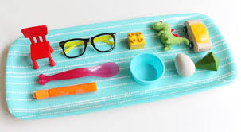  - I Spy Number 6 activity sheet | Part whole models  You might want to start by going through the Number blocks Number 6 power point first.  Just like you did for number 5, can you use the part whole model to explore the number 6?  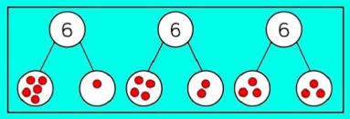  Activity- Numberblocks Dice matching activity
Forming the Number 6  Can you practice writing the number 6? You could use pencils, chalks, pens, shaving foam, sticks in the mud, squirting water from a bottle etc.  The rhyme for this number formation is  (again Skip to My Lou tune)  “Come on down and make a curl (repeat 3 times  To make the number 6.”  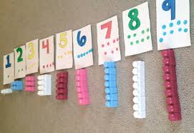  I’ve also attached a formation sheet if you would rather use this or use it as well. | Tens frame  In Nursery we complete a tens frame every single day as part of our daily welcome.  Can children find different numbers of items in the house and then mark them off on a tens frame?  E.g. 2 balls= 2 dots on the tens frame  5 blocks= 5 dots on the tens frame.  (Tens frame sheet attached also.)  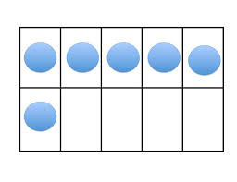  Activity- roll and colour numberblocks activity. | All About the Number 6  Today we are putting together all of the things that we know about the number 6 using this activity sheet.  Are there any parts that you found tricky?  