**Pre-Handwriting – Developmental Continuum**

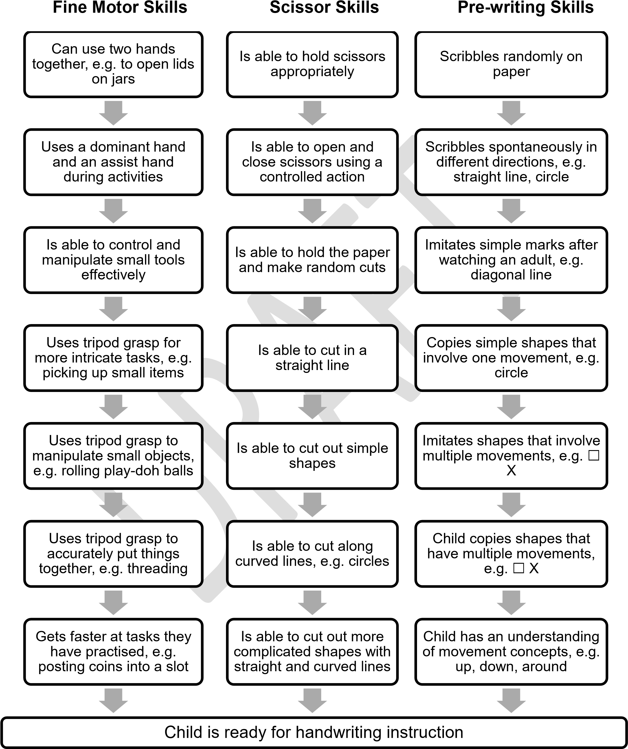

* A child's posture and seating during pre-writing activities can impact on their performance
* It is important that a child has lots of opportunity to develop their gross motor & co-ordination skills

Taken from - Care & Learning Service – Occupational Therapy, Educational Psychology, Speech and Language Therapy