Home Learning Weekly Menus – Summer Term

As our schools continue to be closed to the vast majority of pupils we want to ensure all families have some support for home learning in whatever form that may have in your home. As we have said and continue to do so, there is no pressure in these unusual times. We have shared lots of information with you and will continue to do so. Our advice is to do ‘little and often’ and don’t forget to mix school work with fresh air in the garden, exercise at home and learning new skills.
We will provide the equivalent of daily Maths and English activities as well as a bank of other weekly curriculum activities which you can dip in and out of.
There is no checklist or timetable for families to follow – this would be impossible when trying to juggle multiple children and working from home!
It may be that as parents/carers you are taking it in turns to be with your children so you only have a morning/afternoon/2 hours each day etc. to spend on home learning. You do not need to do all of these things, please be kind to yourselves and pick and choose from the weekly ‘menu’ according to what suits your situation.
A new menu will be added to the website under your child’s year group page by the Friday evening of the previous week.

Year 1 Weekly Menu Summer Term Week 7 Week Beginning 8.6.20
Daily 10 mins |  |  | Phonics link:  https://www.phonicsbloom.com/  Have a go at some of the free phase 4/5/6 games.  Daily Monday-Friday  https://www.youtube.com/channel/UCo7fbLgY2oA_cFCIg9GdxtQ- Read Write Inc sessions. Choose set 2 (10:15am) or set 3 (10:30am). Sessions are live daily but if you miss one do not worry you catch up using the above link.
Daily Lessons | Maths (This week’s work sheets are in resources – like English sheets – rather than found on the White Rose site)  White Rose Maths Home Learning:  https://whiterosemaths.com/homelearning/year-1/  How to use the lessons:  1. Click on the set of lessons for your child’s year group. YEAR 1 SUMMER TERM WEEK 7 wb 8.6.20  - Watch the video  - Find a calm space where your child can work for about 15 – 20 minutes.  - Use the video guidance to support your child as they work through an activity. |  | English  The next three week’s lessons are all based around the theme of ‘The Deep, Dark Forest!’  Also on the Year 1 page are some spellings you could practise.
1 | Practical option:  Count in 2s  Practical Option:  Find lots of pairs of socks in your drawers at home. Place them in a line (in pairs on the floor) and count in 2’s. Or if you would like to you could hang them on a washing or place on the ground outside and use chalk to write in 2s (see image below)  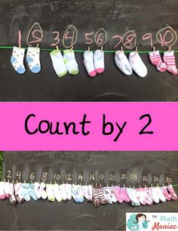 |  | Look at the woodland pictures – what might live here?  Do you know any stories that are set in woods?  Go on an imaginary (or real if you can) walk through a wood – describe what you can see/ hear / small / feel!  Use the description sentence starters to help you describe the wood orally. Use lots of interesting adjectives. You could write down two of your best description sentences if you would like to.
2 | Count in 5s  Practical Option: Counting in 5s hand printing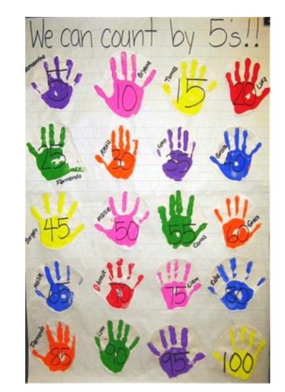 |  | Look again at the deep, dark wood pictures from yesterday.  Choose your favourite picture and write a paragraph to describe the scene. Remember to use some of the sentences you said or wrote yesterday.  Can you use some of conjunctions - and/then/but/so/because?  Can you use capital letters and full stops accurately and an exclamation mark and a comma if you can?
3 | Count in 10s  Practical Option:  Count in 10s when you walk up the stairs. When you walk back down the stairs you could count backwards in 10s. |  | Deep Dark Wood story power point.  Look at the front cover of The Deep Dark Wood – what do you think the book will be about? What do you think will happen in the book? Who will the characters be?  Enjoy the whole book a couple of times – taking it in turns to read with an adult.  Now think of some questions you would like to ask the monster best friend. Write down up to five of your questions – don’t forget to use capital letters and question marks. There are some question words to help you in the resources.  You could ask a grown up to pretend to be the monster and answer your questions!
4 | Add equal groups  Practical Option:  Using objects found in your home (e.g. Lego, marbles, counters, dry pasta, small toys) add equal groups.  e.g. 2+2=  3+3+3=  5+5+5=  6+6+6+6= |  | Enjoy The Deep Dark Wood story again – either read on the power point or listen to the story being read here https://www.youtube.com/watch?v=Sa-0quX70xk  Design your own monster best friend. You could use the planning sheet from the English resources or draw and label your own in your home learning book or a piece of paper. Don’t forget to include some qualities that make your monster a good best friend e.g. fun / patient / helpful. There is a word bank to help you in the English resources.
5 | Family Maths Challenge- see sheet in resources  (answer sheet also available!) |  | Read the character description of The Bobblepof from the English resources with a grown up.  Write your own detailed character description using the monster best friend you designed yesterday.  Can you use amazing adjectives?  Can you use different sentence starters?
Extra Activities | https://www.youtube.com/watch?v=q_yUC1NCFkE  Work out and count in 2s, 5s and 10s with Jack Hartmann. |  | See if you can write some of this week’s spellings into interesting sentences. Can you include capital letters, full stops, exclamation marks, amazing adjectives and conjunctions (and/then/but/so/because)?
Weekly Activities
R.E |  | Our new RE topic is ‘The Gospel’ where Jesus comes to Earth (God in the flesh) to restore the friendship between God and Humanity. The story of Jesus’ life is told in a new kind of book, a ‘Gospel’ or ‘Good News’ book.  This week we will be thinking about the gifts that Christians believe God has given humans and how God is like a parent or ‘Father’ to them.  Discuss the activities on the RE resource sheet with a grown up.
Creative |  | Our inspirational artist this half term is Andy Goldsworthy. This week we are going to work in a similar way to last week but instead of using objects found in your home I would like you to use natural materials such as pine cones, pebbles, feathers, twigs, leaves, bark, grass and flowers. Can you make a nature picture inspired by Andy Goldsworthy’s artwork? Remember to think carefully about pattern, texture and colour when making your design. When finished you could discuss your artwork with a grown up or you could take a photo and email it to us describing your creative choices.
History / Geography |  | Look at the power point (see resources). Discuss the features of the seaside with a grown up. Complete the seaside sort on slide 17 of the power point. In your books record a list of the human (manmade) and the physical (natural) features of the seaside or complete the sheet in the resources.
P.E. |  | https://www.youtube.com/watch?v=lc1Ag9m7XQo Try this online kids HiiT work out  Practise catching and throwing – under arm/over arm / bouncing the ball in the middle! Can you find different items to practise with? E.G bean bags, pairs of socks, teddies.
Online Games/Links |  | https://www.booktrust.org.uk/books-and-reading/have-some-fun/storybooks-and-games/ Check out this book trust website for lots of online books to read and fun games to play.

