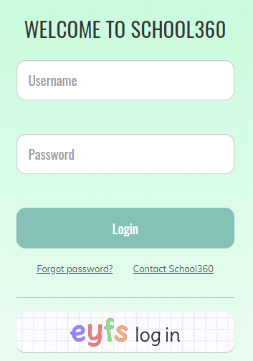
Log on to www.school360.co.uk and select EYFS log in

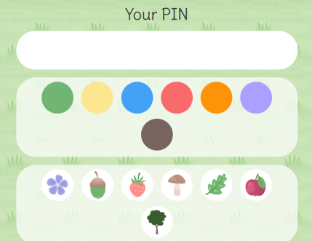

Enter your child’s details (over time children will be able to do this independently)

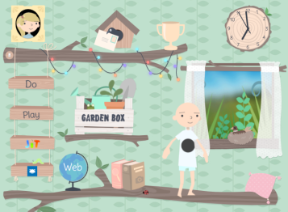
Confirm it is your child then you should be taken to their tree house!

Select the ‘teacher’ icon in the top left to be taken to the teacher’s choice page. Select ‘teacher’s cupboard’ for some games I have added to 360 (beware though some of these don’t work on tablets/ipads!)
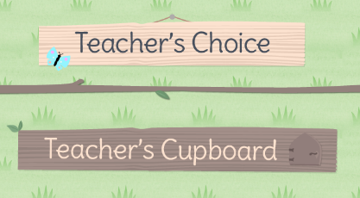
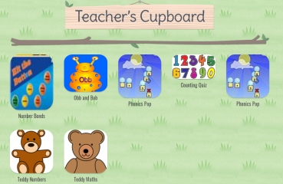
I have also placed some links to relevant games on the web link at the bottom of the page (the globe!)
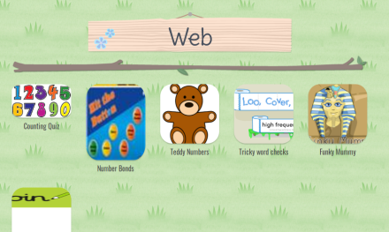

The children have spent some time this week ‘spending’ their 360points dressing their avatar. This is how you do it ….
Click on their avatar (person) and you’ll be taken to the ‘shop!’ Here, you can spend points updating your avatar. There are hairstyles, clothes and animals to ‘buy’ some are free and others have a point charge. You can see how many points your child has accumulated on the screen as shown below. Always click ‘save’ otherwise the avatar will return to the outfit they were wearing on previous visits to the site.
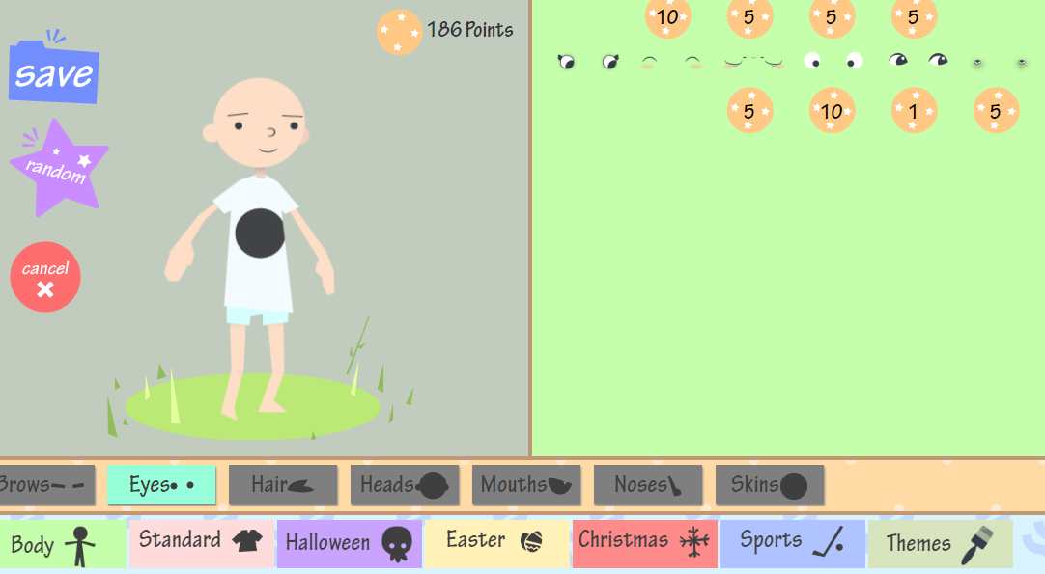

To return to the treehouse select the home icon at the top of the screen (after you have selected save even if you have made no changes!)
Spend time exploring the different options in the treehouse. Some of the games on the ‘jit’ page are for older children but let me know via Tapestry if there are any that your child is particularly enjoying so that we can explore them further in school!
Thank you
EYFS Team

