Your child needs to know how to read and write all of these Common Exception Words by the end of Year 1.
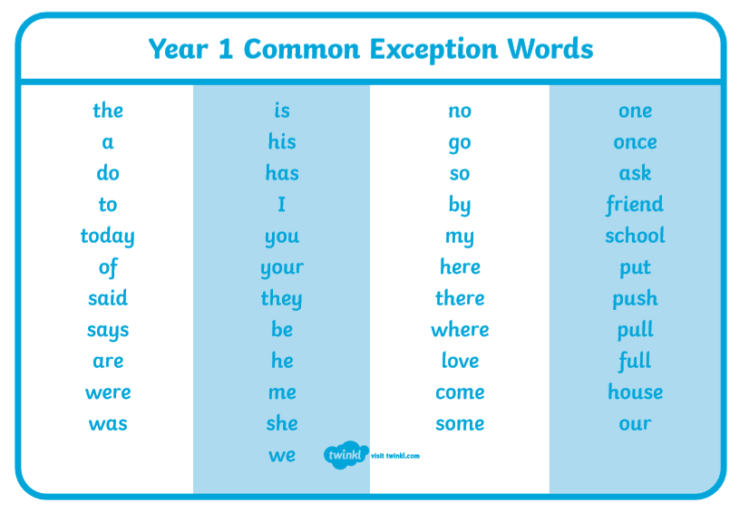
The words highlighted/outlined are the words to learn this half term. Please can you:
- Read these words with your child so they can sight read them.
- Discuss what each word means.
- Teach your child how to spell each of the words.
Possible activities once they have learnt how to read and write the words:
- Put the words into sentences.
- Make a word search with the words. Make a sight word memory game. Write each sight word on two different index cards. Then turn the cards over and invite your child to find the matches.
- Play word bingo with the words
Please feel free to speak to me if you have any questions.
Thank you
Miss Baxter

A1 – 8 A2 – 8 Sp1 – 8 Sp – 7 S1 – 7 S2- 7

