Topic challenges  Week beginning 18.1.21  This week our topic challenges are based on our topic “Long, long ago: Dinosaurs”  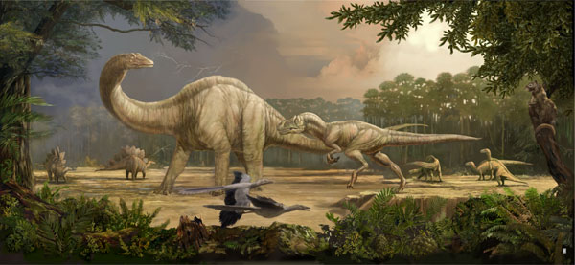 | PSHCE My Happy Box  Please see attachment for this task | Every person is unique and valuable  Talk about occasions when things have happened in your life that has made you feel special.  Find one or two photos at home of a special event and discuss it/them with your grown up. What you are doing in the photo and why is it a special time in your Life. Draw a picture of a special event in your life and with a grown up’s help, write a short sentence about it. For example, It was my birthday, We went to the beach, I had a big cake.
Dinosaur Skeletons  Using cotton buds, glue and paper (a dark colour like black or dark blue would work best for this). Create pictures of dinosaur skeletons using the cotton buds as the bones. You could look at the dinosaur skeleton photos I have attached for ideas.  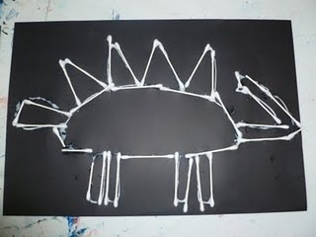 | Cooking Challenge  Make chocolate cornflake dinosaur nests with a grown up. You could even add mini chocolate ‘dinosaur’ eggs. A lovely way of exploring the changes that take place when melting chocolate.  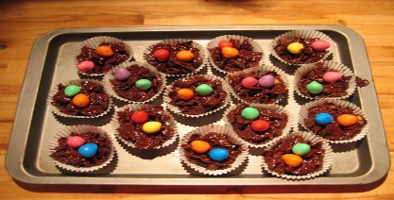  This Photo by Unknown Author is licensed under CC BY-NC | Listening and singing Challenge  EYFS: Listen and Play - Dinosaurs - BBC Teach  Use the link above to listen to Cat as she encourages you to listen carefully and to recognise and identify various sounds: jungle sounds, dinosaurs roaring, stomping sounds. Cat then invites you to join in with stomping, stamping, dinosaur actions and loud roaring sounds as you listen and sing along.

