- Topic challenges  Week beginning 25.1.21  Our topic challenges are based on our key text this week, which is ‘Zog’ by Julia Donaldson.  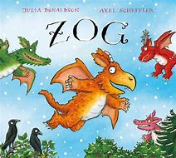 | Design a crown  Can you design and make a crown fit for a Princess?  Maybe you could add some 2D shapes to your crown and tell your grown up which shapes you have chosen?  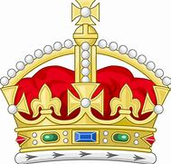 | Make a fire breathing dragon  Can you make your own fire breathing dragon?  If you don’t have many junk model materials to hand,you could simply use paper and add coloured paper fire strings.  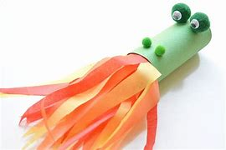
Fantastic First Aid  Princess Pearl is so kind, always helping Zog when he is hurt.  Can you think of some things that you might put in to a First Aid box?  Could you draw a First Aid box and all of the things that you will put in it?  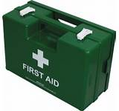 | Design your own dragon egg  Ask a grown up to draw an egg shape for you on some paper. Can you colour your very own dragon egg? Maybe it will be as colourful as a rainbow, or full of spots or stripes?  I can’t wait to see what you come up with.  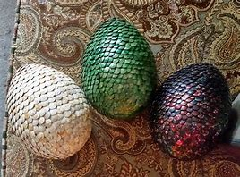 | Super singers  I’ve attached some topic themed power points for you to use with lyrics (unfortunately I am not able to add the backing tracks.).  Can you have a go at singing some of these songs?  The Castle on the Hill  Who Will Fight the Dragon  The King in the Castle  The Brave Knight  