Reception

**Secondary Curriculum Driver: CL (Communication and Language)**

**Intended outcome:**

Children can listen to stories with increasing attention and recall.

Listens and responds to ideas expressed by others in conversation or discussion

Children are beginning to understand ‘why’ and ‘how’ questions.

Uses language to imagine and recreate roles and experiences in play situations.

Introduces a storyline or narrative into their play.

**Proposed learning opportunities:**

Listen to and ask questions about how and why people around the world participate in different celebrations. What do the celebrations look like?

Share what celebrations children participate in and what it looks like. Are there any similarities or differences between their celebrations and their peers?

Explore and develop kindness, celebrating others, differences and uniqueness through daily Special Person time.

**Primary Curriculum Driver: PSED (Personal, Social and Emotional Development)**

**Intended outcome:**

Children can play in a group, extending and elaborating play ideas, e.g. building up a role-play activity with other children.

Children can explain their own knowledge and understanding, and asks appropriate questions of others.

Children are able to listen to others’ ideas and take in to account what other people say.

Children are confident to talk to others when playing, and will communicate freely about own home and community.

Children can talk about themselves in positive terms and talk about abilities.

**Proposed learning opportunities:**

Circle time sessions finding out about seasonal changes and different celebrations around the world. How and why celebrations occur.

Small group time activities, to promote speaking and listening skills, mathematical concepts and early writing development.

Seasonal display of items of interest relating to the season or topic, to generate discussions between the children.

Children work together to create and perform in our Christmas performance.

Autumn 2

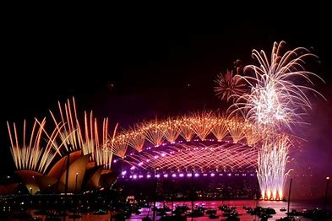

Bright Lights and Autumn Nights

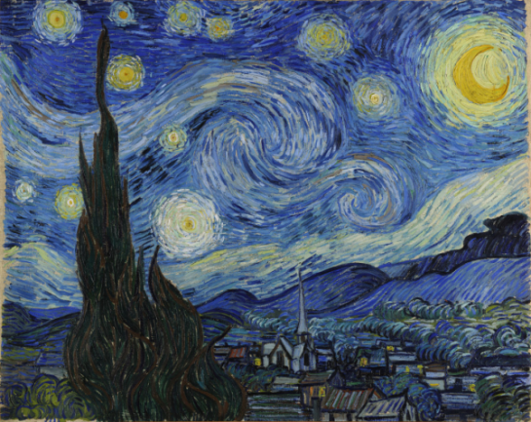

**Literacy:**

**Proposed learning opportunities:**

Recognise and write own name.

Set 1 and 2 RWI Speed Sounds.

Begin to hear and continue rhyming strings.

Predict endings to stories and talk about characters.

Understand that stories have a beginning, middle and end.

Key texts: Squirrels Autumn Search, After the Storm, Non- fictional texts for celebrations and seasons.

**Mathematic Development:**

**Proposed learning opportunities:**

We follow White Rose Maths scheme in Reception and throughout school.

During this term we will be exploring;

* Measure
* Patterns
* It’s Me 1,2,3
* Circles and Triangles
* 1,2,3,4,5
* Shapes with 4 sides

Learning is further supported through enhanced continuous provision.

**Physical Development:**

**Proposed opportunities:**

Large scale activities such as outdoor play, bikes, scooters and those relating to developing early writing.

Develop and strengthen hand muscles through Dough Disco and Funky Finger activities.

Use various tools and equipment.

Begin to form letters correctly.

Join in with the class Santa Dash.

**Understanding World:**

**Proposed opportunities:**

Understanding rules for school and the reasons why we have them.

Celebrations around the world; Diwali, Christmas.

In school events; Road Safety, Be Bright, Be Seen, Remembrance, Bonfire Night, Children In Need.