Topic challenges  Week beginning 22.2.21  This week our topic challenges are based on the story, ‘What the Ladybird Heard’ by Julia Donaldson.  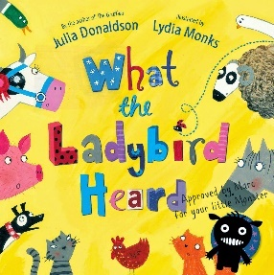  You can begin by listening to the story. We’ve suggested these follow up activities to consolidate a range of reading, writing and creative skills previously taught in school. | Animal Song  Can you make up a song which includes lots of examples of animal sounds? Get some ideas by watching this performance of a song by Julia Donaldson and her husband:  https://www.youtube.com/watch?v=7NbyiDpY6Ww  Perhaps you could perform your song for your family. I would love to see a video of your performance! | Traps  Can you make a trap using construction to help the police catch the baddies?  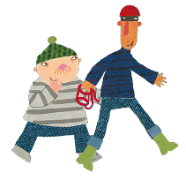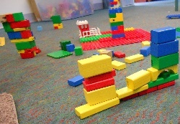  How does yoiur trap work?
Ladybird Craft  Create your own ladybird. You could use Playdough, Lego design, paper plate ladybird. Be creative!  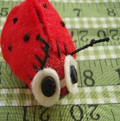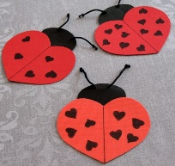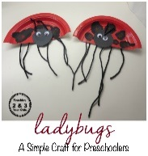  This Photo by Unknown Author is licensed under CC BY-ND  This Photo by Unknown Author is licensed under CC BY-ND  This Photo by Unknown Author is licensed under CC BY-NC-ND | Computing Activity- My Favourite Food  During this topic children will need access to a drawing/ painting app or program. Here are some suggested free apps: Paint Free-Drawing Fun, Kids Paint, Windows paint application  Have you ever created art using a computer, tablet or iPad?  Draw a picture of your favourite food using one of the paint/ drawing applications above. Think about its colour, texture, is it hot or cold, is it served in a bowl, plate or something else?  Remember to save or screenshot your work when you have finished.  Once you have finished show someone in your family your picture, do they know what you have drawn? Discuss with a grown up how you could make your picture even better next time. Are there any features you haven’t explored? | RE Activity-Who were Jesus’ friends?  Watch the story of Jesus washing the disciples feet https://youtu.be/bv5ajWNrnt4  What kind of man was Jesus? Jesus had many followers and he had 12 disciples who were his special friends.  Make a card for a special friend of yours and tell them why you think they are special.

