Squares, circles or hearts,
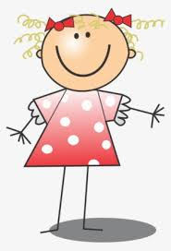
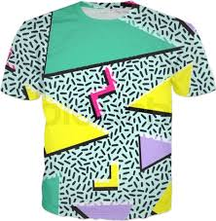
Dots, zigs or zags,
T-shirts, dresses and socks,
Hairbands, skirts and even handbags!
Can you design your own patterned outfit fit for a Prince or Princess?

