Topic challenges  Week beginning 8.6.20  This week our topic challenges are based on the story, ‘Princess Mirror Belle and the Dragon Pox.’  You can begin by listening to the story. We’ve suggested these follow up activities to consolidate a range of reading, writing and creative skills previously taught in school.  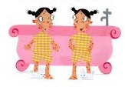 | Monday – What does every princess or wizard need?  The story is about a little girl called Ellen who looks in to the mirror and sees her mirror self- Princess Mirror Belle. Can you make your own magic mirror? You could use different coloured paper, pencils, paint it, wrap it with ribbon and even cover it with magic glitter.  Could you upload your magic mirror photograph onto Tapestry so that we can see your brilliant work too?  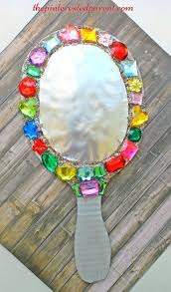 | Tuesday – Spotty dotty  Ellen and Mirror Belle were covered in spots.  How many things can you find in your home that are all spotty?  Can you find any other patterns, e.g. zig zags, swirls or even spirals like we looked at last week.  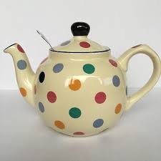
Wednesday – Design a patterned Princess or Prince outfit.  Princes and Princesses love to wear jazzy clothes! Can you design an outfit for a Princess or Prince which has shapes or patterns on?  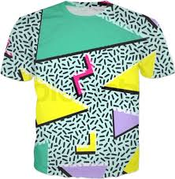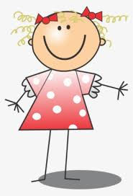 | Thursday – Spot the Difference  Look at the resource sheet picture.  Can you find all 5 differences between the 2 pictures. You will have to look carefully as they are quite tricky to spot!  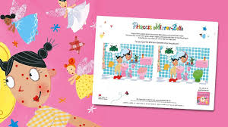 | Friday- the messy activity (sorry.)  Is there a Doctor in the house?  You will need a bath or a bowl of water for this activity.  Can you create your own potion to help cure dragon pox? What do you have in your house that you could use? What will food colouring and fairy liquid do to the water? What does shaving foam look like in the water? Does glitter float? *(Sorry mummies and daddies!)* 