Be Safe Be Active Home Learning Activities
Name | Sprints
Equipment | • Two markers: Can be literally anything
Description | Create a track by laying markers at the start and end. You can make the track as small or large as you like. Each contestant has 60 seconds to run as many lengths (there and back) of the track as they can.
Scoring | 1 point is awarded for each full length (there and back)
Name | Standing long jump
Equipment | - One marker  - A tape measure
Description | Place a marker on the floor with empty space in-front of it. The contestant stands level with the marker and jumps forward. They should take-off and land on two feet. If they fall over when they land, they take their turn again until they land on two feet.
Scoring | 1 point is awarded for each 10cm jumped. Use the tape measure to measure from the marker to the back of the contestant’s foot (the nearest part of the foot to the marker).
Name | Target practice
Equipment | - One marker  - A target container: Bucket, large saucepan, washing up basin, etc.  - Throwables: Small beanbags, balled up socks, or anything throwable that isn’t too bouncy.
Description | Place a marker on the floor and then place the target container in-front of the marker at a distance of your choosing (the further the distance the harder the challenge). Place the throwables next to the marker. The contestant has 60 seconds to get as many throwables into the container as they can. If they miss the target container, they move to where the throwable landed and take their next shot from that position. Once they get the throwable into the target container they move back behind the marker and pick up the next throwable. Once all three throwables are in the container the contestant can retrieve them and keep playing until the timer runs out.
Scoring | 1 point is awarded for each throwable landed in the container.

Name | Egg and spoon race
Equipment | - Your sprint track from the first event  - A spoon (big enough to hold an egg)  - Hardboiled egg or alternative item
Description | The contestant starts behind the first marker holding an egg balanced on a spoon. They have 60 seconds to complete as many lengths of the track as they can. If they drop the egg, they need to rebalance it on the spoon and start again from the position the egg dropped.
Scoring | 2points are awarded for each full length.
Name | Assault course
Equipment | • Random objects of your choosing
Description | Create a safe assault course using random items of your choosing. For example, you could have a duvet they need to crawl under or flowerpots that they walk across like steppingstones. Be as creative as you can, but make sure it is safe. The contestant has 60 seconds to complete as many circuits of the of the assault course as they can. When they get to the end they run back around to the start the next circuit.
Scoring | 2points are awarded for each full circuit.
Name | Sack Race
Equipment | - Your sprint track from the first event  - Sacks: Pillowcases, bin bags, or alternative
Description | The contestant has 60 seconds to complete as many lengths of the track as they can, with their feet inside the sack. They use two footed jumps to move forward.
Scoring | 2points are awarded for each full length.
Name | Dance-off
Equipment | - A space to dance  - A music player
Description | Each contestant must plan and perform a 60 second dance routine. It can be to any music and in any style they choose. In turns the contestants perform their dance routines for each other.
Scoring | 3 points are awards for each 20 seconds performed (maximum 9 points).
Name | Clock Jump
Equipment | • 4 markers
Description | Lay out 4 markers at the 12, 3, 6 and 9 positions of a clockface (each roughly 3 feet from the center point). The contestant starts stood in the center of the markers. Once the timer begins, they must jump towards each marker and back. So, for 12 they jump forwards and then back, for 3 they jump right and then left, for 6 they jump back and then forwards, and for 9 they jump right and then left. Once they get round to the 12 they start again, completing as many rotations as they can in 60 seconds.
Scoring | 2points are awarded for each full rotation of the clock.
Name | Bottle flip
Equipment | - An empty plastic 500ml water bottle  - A table
Description | Put roughly 125ml of water into the bottle and screw the cap on tightly. The contestant must try and flip the water bottle onto the table, getting the bottle to land upright. The have 60 seconds to complete as many landings as they can. If the bottle doesn’t land upright just pick it up and try again.
Scoring | 2points are awarded for each completed landing.
Name | Dizzy divas
Equipment | - Your sprint track from the first event  - A stick: Short broom, cricket bat, etc.
Description | The contestant starts behind the first marker. They put the stick to their forehead and then (looking down) complete 10 full 360-degree rotations. Then they must run to the second marker and back. Once back they complete another 10 rotations before setting off again. They complete as many lengths of the track as they can in 60 seconds.
Scoring | 3 points are awards for each full length.

5
Scorecards:
Event 10

Event 9

Event7

Event8

Event 6

Event 5

Event4

Event 2

Event 3

Event 1

Names

Print them out, fill them in and use string to turn these templates into awesome medals. It’s up to you how you award the medals. You might decide to do it based on scores or you can use our suggested system:
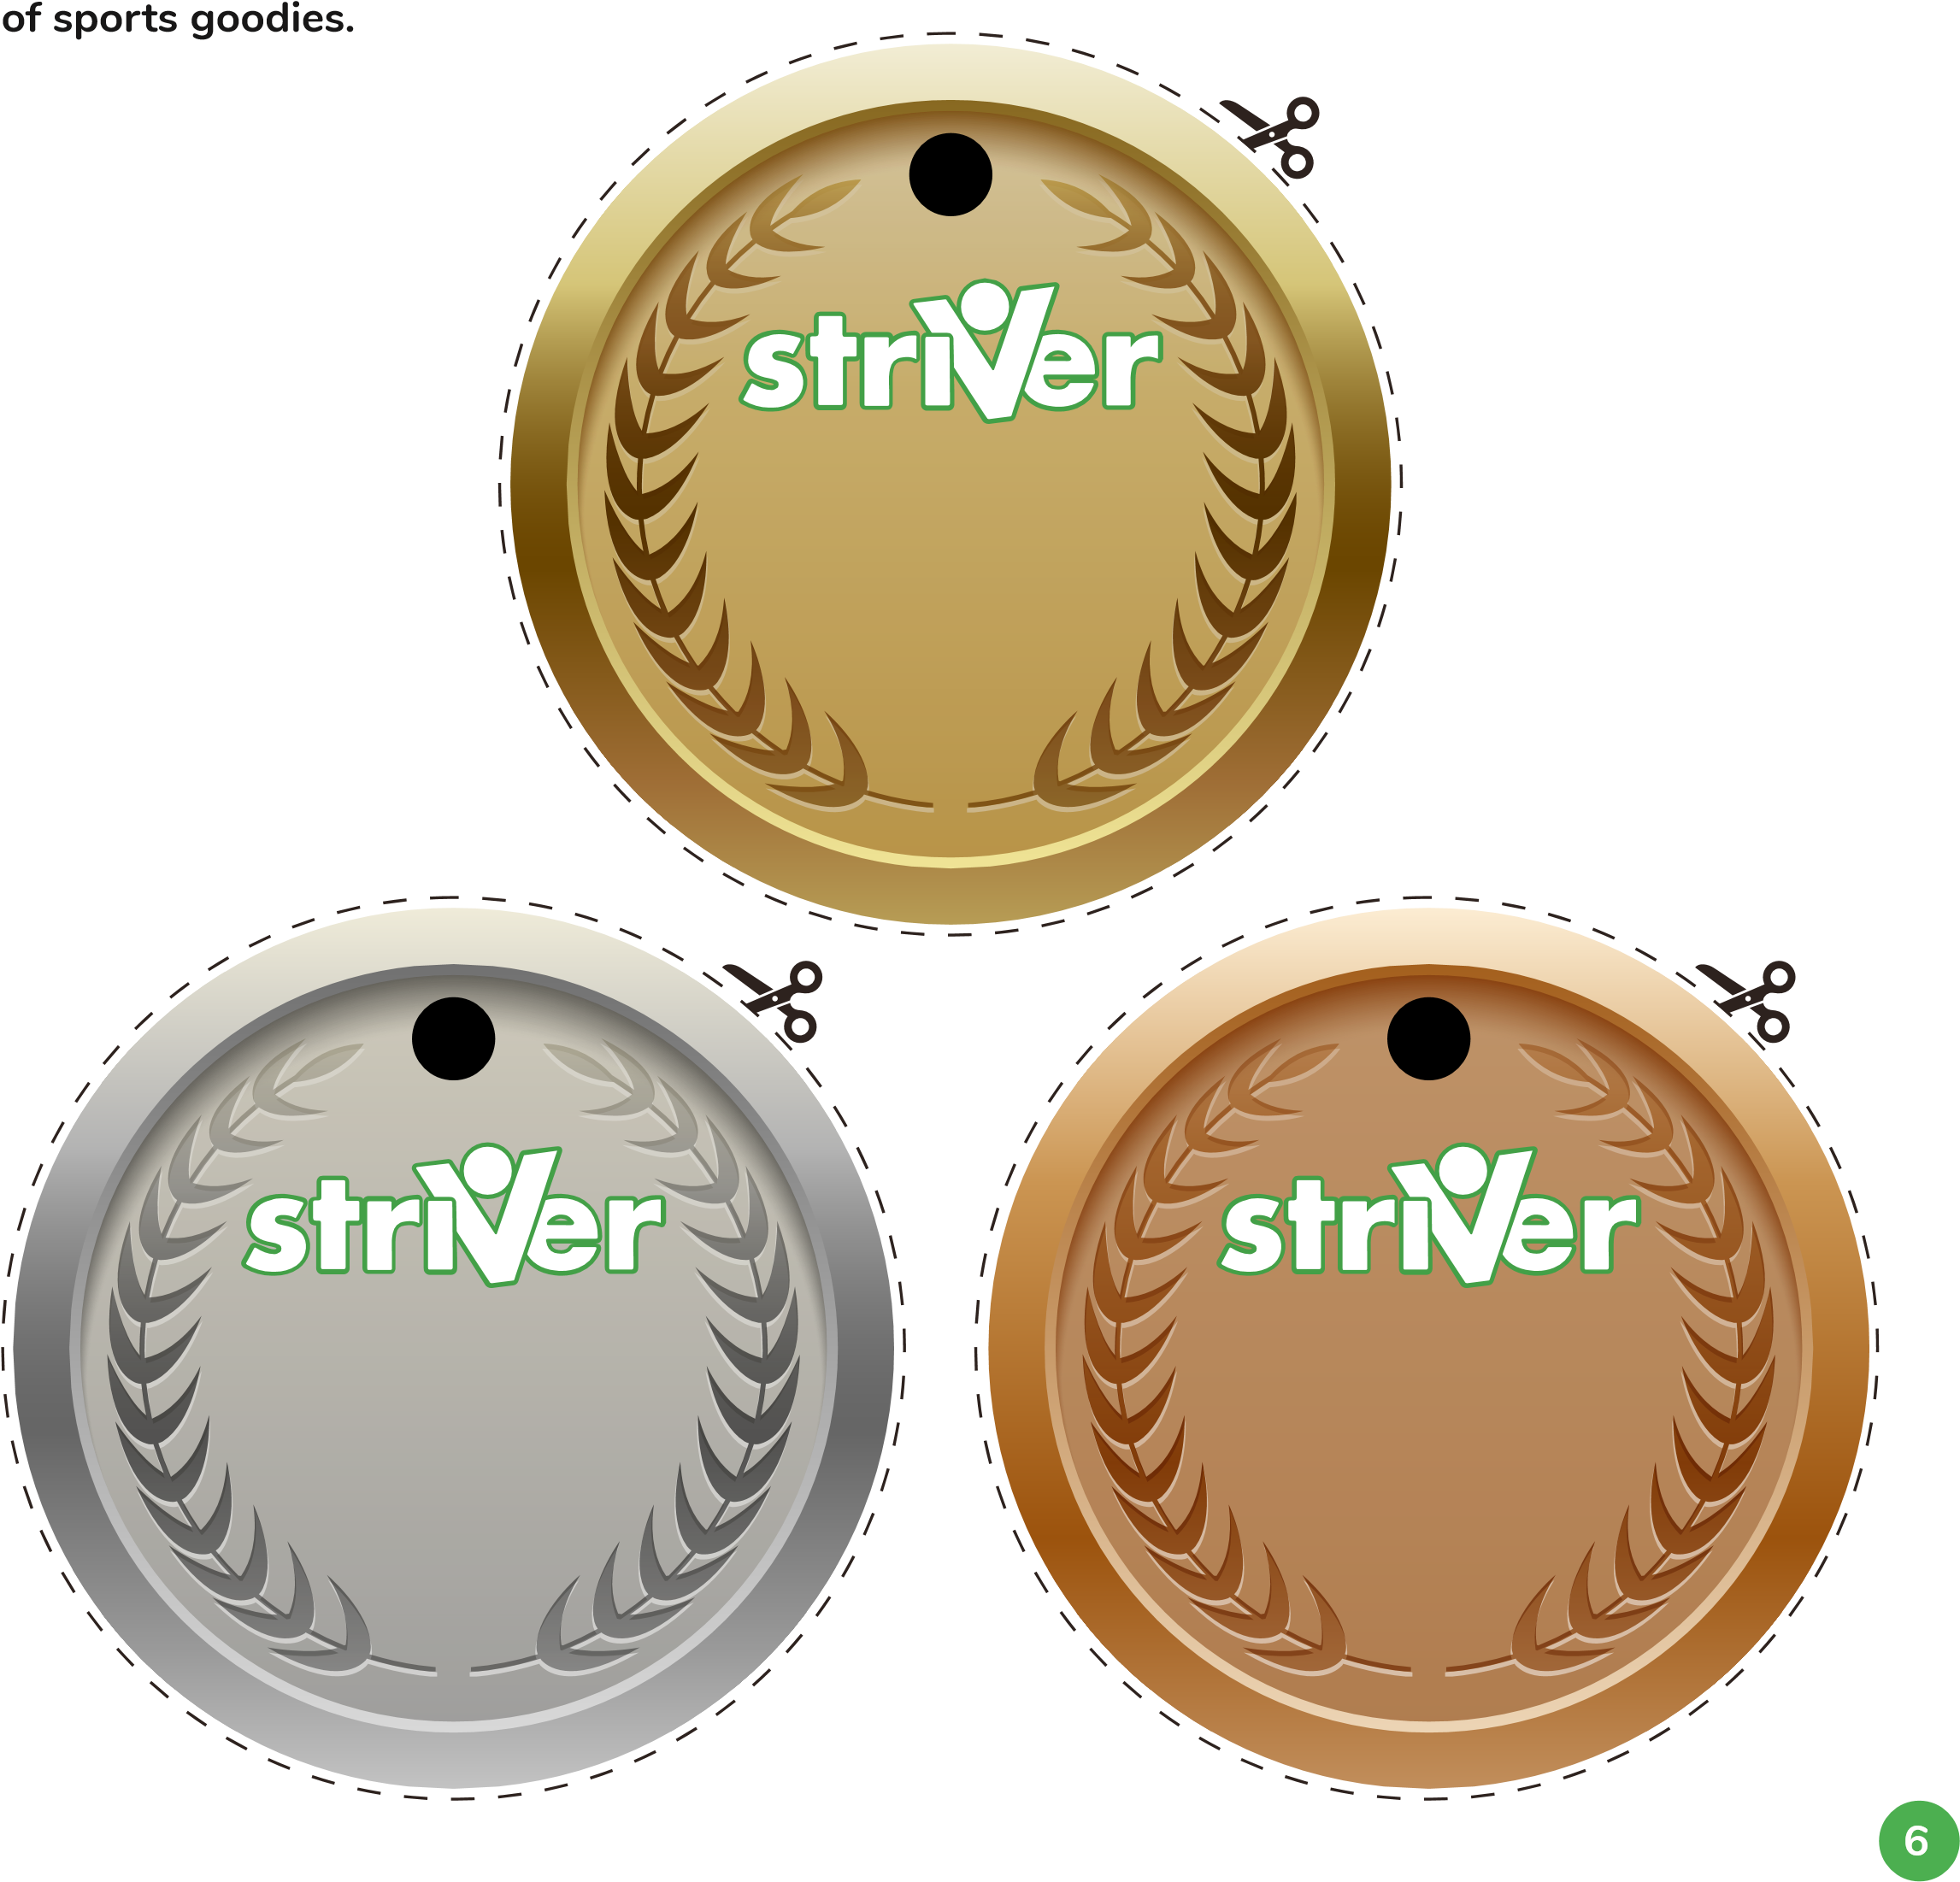
- Bronze: For people who took part in at least three events.
Medals and awards ceremony
- Silver: For people who took part in at least 7 events.
- Gold: For people who took part in all 10 events!
We’d love you to share a picture of your award ceremony with us on Twitter - @2s_wellbeing.
Share with the hashtag #StriverSportsDay to be entered into our competition to win a hamper

