Literacy challenges  Week beginning 1.2.21  This week our literacy challenges are based on the story, ‘Zog and the Flying Doctors’ by Julia Donaldson. This follows on from our super work last week on Zog.  It is also on iplayer too, the link is below  BBC iPlayer - Zog and the Flying Doctors  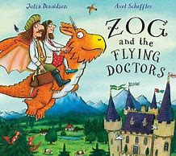 | Monday-name writing  Can you practice writing your name today? Maybe you could use all of the different colours of the dragons too?  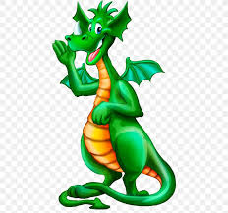 | Tuesday – Who will they help next?  Imagine that Princess Pearl, Zog and Sir Gaddabout help another person or animal. Who would it be?  Maybe they help a woodland creature who has a sore foot, or a giraffe who has banged its head. Could you draw this new page in the book? 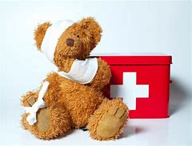
Write it Wednesday  Can you write (mark make) a ‘Thank You’ card for the Flying Doctors?  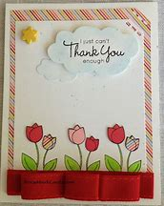 | Thursday – creative castles  With a grown up use the internet to find out about castles. Do they all look the same? What do they have? Who lives (ed) in castles?  Could you draw or make your own castle? You could use junk model materials, tins from the kitchen, blocks or pen and paper.  I can’t wait to see what you create.  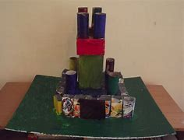 | Friday –King of the Castle  Can you use the internet or information books to find out who lived in castles a long time ago? There was more than just the King and Queen. Maybe you could draw some of them and ask your grown up to label them, or maybe you could tell me some of the people and their jobs that you found?  