Literacy challenges  Week beginning 1.6.20  This week our literacy challenges are based on the story, ‘Ten little rubber ducks’.  You can begin by listening to the story. We’ve suggested these follow up activities to consolidate a range of reading and writing skills previously taught in school.  https://www.youtube.com/watch?v=fCpNRTb5tOQ | Monday – draw the pictures of the animals that the rubber ducks went past  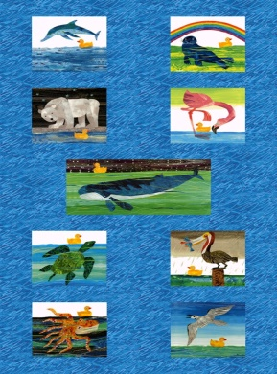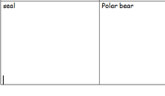  Sheet attached | Tuesday – Phonics- Tricky words  Some words try to trick us because we do not write them the way they sound. Today we are learning ‘no’.  How many times can you write it? Can you write it in different colours? Who can write it first, you or your grown up?  If you have any post its, you can write ‘no’ and stick them around your house, then every time you pass one, say ‘no’ in your LOUDEST voice, your quietest, squeakiest, and growliest voice.
Wednesday - Phonics You Tube Ruth Miskin  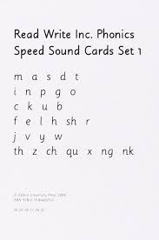  Listen to these sounds on youtube, can you say them as clearly? Remember not to add the ‘uh’ on the end of each sound.  In Nursery, we have not yet covered ‘qu’, ‘ng’ or ‘nk’ but you could always listen to them and see if you can learn them yourself. | Thursday – Write a postcard to a friend with your grown up, maybe they can write the words and you think of some wonderful ideas?  Imagine that you were one of the ducks and had been on an adventure, tell your friend all about it.  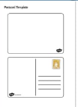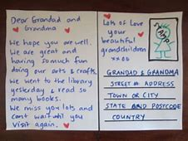 | Friday – Write your own sentences for the story with your grown up.  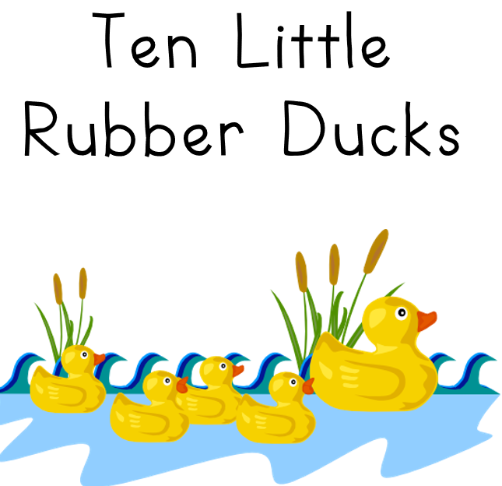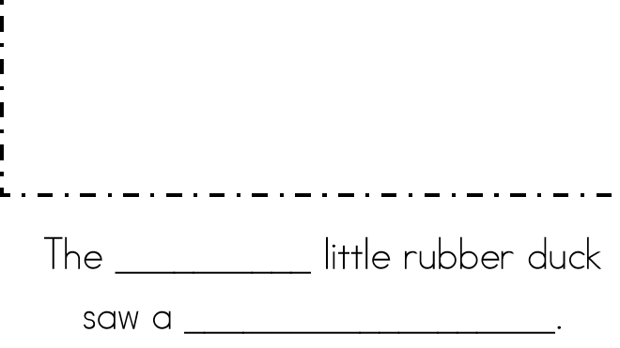  You could be as imaginative as you like.  The 1st little duck saw a rainbow.  The 2nd little duck went past a shark.

