**C&L (Communication and Language)**

*Core Texts: ‘Little Red Riding Hood’*

*‘The Gingerbread Man’*

*‘The Three Little Pigs’*

*and*

*‘Jack and the Beanstalk’*

* Daily story time
* Practise listening attentively and respond to what they hear with relevant comments
* Encourage speaking in full sentences using the correct tense.
* Talk about different characters in stories and make simple predictions.
* Talk about why they are special
* Talk about themselves and their families during play or news time.
* Role play stories using puppets and or costumes and props
* Fairytale Shop

**PSED (Personal, Social and Emotional Development)**

* Daily Special Person linked to our Christian values
* Snack times / daily circle times
* Prayer times
* PSHE stories, songs, videos
* Independence in toileting, handwashing, getting dressed for PE, changing wellies, fastening own coats and taking responsibility for their belongings
* Knowing and following the Corbridge School Calm Code

**EYFS Curriculum**

**Traditional Tales**

**Spring 2 2024**

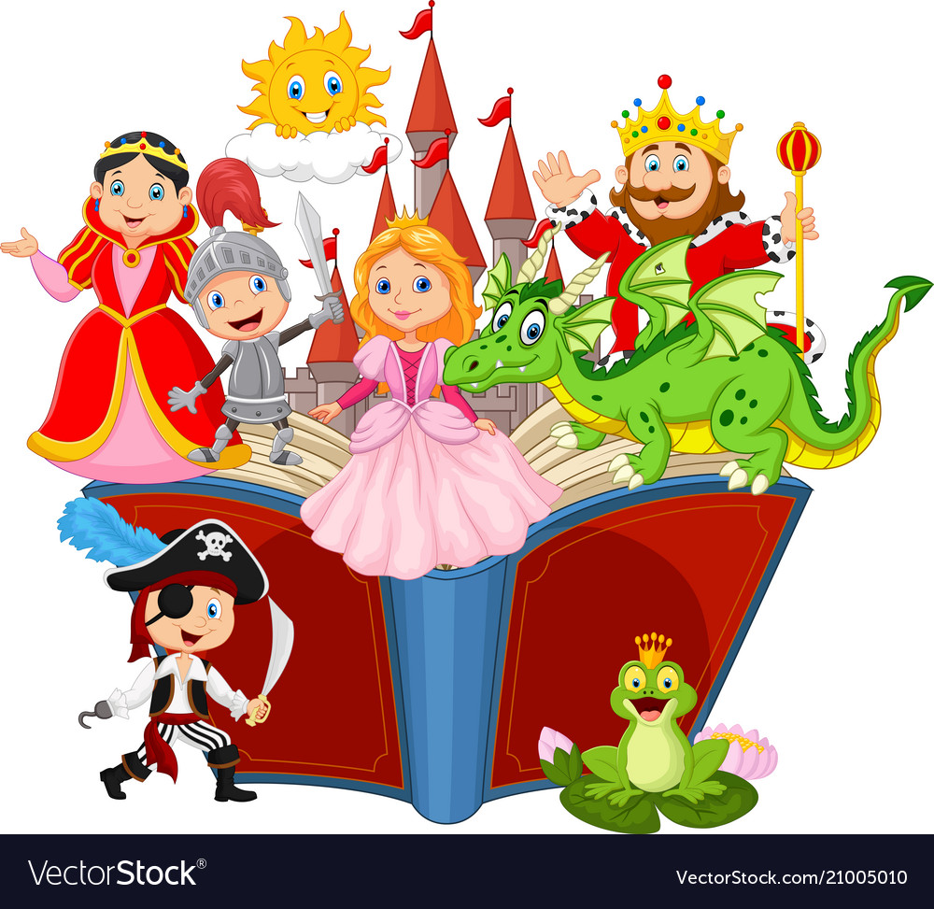

**PD (Physical Development)**

**Gross Motor**

* Daily outside play on large equipment
* Bikes & scooters
* Running track
* Weekly PE Lessons with Mr Thompson
* Weekly forest school sessions

**Fine Motor:  Pinching, tweezing and twisting, cutting and spreading**

* Play-dough / gloop
* Using one handed tools such as scissors, paint brushes, glue sticks and tweezers
* Threading beads, weaving with pipe cleaners and wool
* Construction area
* Mark making
* Colour mixing

**Don’t forget …**

* A spare change of clothes, labelled, to stay in school
* Check **all clothes are labelled**
* **Named wellies** to stay in school
* Water bottles sent into school daily
* Regular Tapestry updates from school – feel free to add your own messages and photos and we will share in News time.
* Check your parentmail account regularly
* Visit our school website for further information [www.corbridgefirst.northumberland.sch.uk](http://www.corbridgefirst.northumberland.sch.uk)
* We will also tweet on Twitter - @CorbridgeFirst

**UW (Understanding the World)**

* Christian values/ Prayers
* Weekly Jack in the Box worship
* Weekly RE lessons: Salvation/Easter celebrations
* Visit to St. Andrew’s to learn about Baptism
* Making and following a simple maps (to get to Grandma’s house).
* Comparing past and present, looking at characters, settings and events in stories.
* Seasonal changes
* Growing beanstalks
* Weekly Forest School Sessions

**Mathematics**

Following **White Rose Maths**, we will cover the topics in our daily group sessions:

* Growing 6,7 and 8
* Length, Height and Time
* Building 9 and 10
* Explore 3D Shapes

Other daily maths opportunities:

* Share date, visual timetable, and number of children daily.
* 1:1 counting of children when lining up
* Daily number songs and rhymes
* Measuring out playdough or cooking ingredients
* Counting objects, maths games and puzzles, timers, 2D and 3D shapes, dominoes, measuring equipment etc available during continuous provision.
* Weekly adult directed tasks to support 1:1 counting, number recognition, recognising (subitising) amounts to 5 and 10, finding pairs of numbers which make every number to 10, comparing amounts and finding 1 more and 1 less.

**Literacy**

Daily Read Write Inc. Phonics Groups:

* To recognise and write all set 1 letters of the alphabet and the special friends sh, ch, th, qu, ng and nk. To learn some set 2 sounds such as ee, oo, ay, ow
* To read words with 3 or 4 sounds through saying each sound and then blending them together. (Fred talk)
* To write words through counting the sounds in a word and writing them down to spell simple words
* Small group reading

Literacy in the classroom:

* Daily whole class and group stories to develop comprehension, inspire writing activities or role play and to foster a love of reading.
* Weekly adult directed tasks to encourage writing for a purpose and using reading skills
* Writing opportunities in continuous provision

e.g. Write name on every drawing or artwork, access to a variety of writing and mark making materials e.g. pencils, chalk, felt tips, paper, post-it notes, tracing paper, role play writing in The Fairytale Shop.

**Expressive arts and design**

* Make fairytale masks for role play
* Design and make fairytale sock puppets
* Design and make the ‘Three Little Pigs’ Houses
* Design and make a gingerbread house using junk modelling
* Make gingerbread biscuits
* Sorting healthy and unhealthy food from Red Riding Hood’s basket.
* Retelling and performing traditional tales using props.
* Painting and printing with different media
* Colour mixing
* Weekly music sessions with Mr. Reed
* Movement and dancing to music.

**Help at home by …**

* Support your child with their **Reading Book** at home and writing in their reading diary three times a week.
* Practise reading and writing sounds from their **Green Sound Book** they have learnt in a variety of contexts e.g. with pens, chalk, in sand, outdoor materials, magnetic letters
* Encourage everyday **Maths –** measuring when baking/cooking, playing board games/dominoes, sorting objects, sharing out items, using money, shape and number hunts.