Topic challenges  Week beginning 22.6.20  This week our topic challenges are based on the story, ‘Zog’ by Julia Donaldson.  You can begin by listening to the story. We’ve suggested these follow up activities to consolidate a range of reading, writing and creative skills previously taught in school.  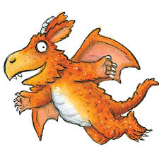 | Monday – Design your own shield  Knights carried shields to protect them in battle. Can you design (or make) your own shield? Often they carried shields with their own particular designs on, so that they could easily be recognised when their faces were covered by their helmets- this is called a Coat of Arms.  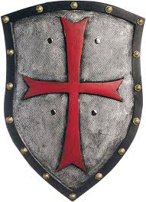 | Tuesday – Who lived in a castle?  Lets find out more about castles and who lived in them. Castles were full of people who all had different jobs. Which job would you have liked to do best?  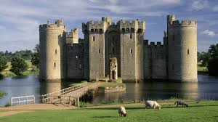
Wednesday – Design or make a crown  Kings, Queen, Princes and Princesses wore crowns to show others that they were important. Can you decorate (see resource sheet) or make your own crown? We would love to see some pictures of your work.  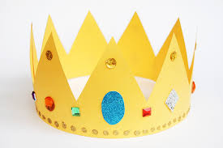 | Thursday – Build a castle  Can you build your own castle? You could use blocks, boxes or even tins. What features does your castle have?  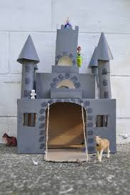 | Friday- make your own dragon  Zog was a big, but gentle dragon. Can you make your own dragon? Maybe you could use split pins or treasury tags to make your dragon move?  