Literacy challenges  Week beginning 22.2.21  This week our literacy challenges are based on the story, What the Ladybird Heard by Julia Donaldson.  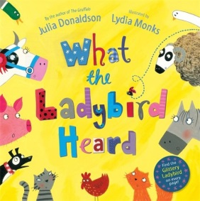  I’ve suggested these follow up activities to consolidate a range of reading and writing skills previously taught in school. | Monday – Ladybird Hunt  Please watch my video- I will introduce and read the story. Can you join in with the animal noises?  At the end discuss what you liked and didn’t like. If you find something puzzling perhaps a grown up can help you understand the story.  Look at slides 2-15 on the power point- can you spot the ladybird on each page of the book? | Tuesday – Book Talk  Look carefully at the maps from the beginning and end of the story (see power point slides-17 and 18). Can you describe what you can see? What do you already know about farms and farm animals? Can you remember where different parts of the story happened?  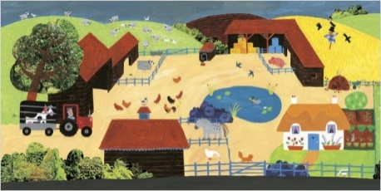  Listen to Miss Jewitt re-read a part of the story. Can you use the map (slide 20) and follow the route the robbers took?  Challenge: using the map can you pretend the prize cow is hidden somewhere different? Can you give your grown-up instructions on how to find it?
Wednesday- Map Making  Can you remember and explain the robbers ‘Cunning Plan’?  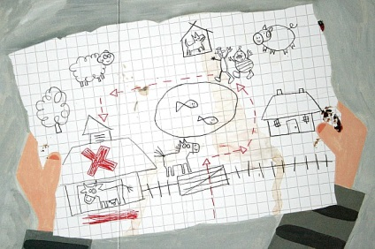  Imagine that you are going to take a trip round the farm and steal the prize cow from her barn. Make your own map showing the route you will take. I wonder what animals/ places you will have on your farm? | Thursday- Exploring Direction  Explore direction using the Beebot Emulator. Can you use directional language to describe the path the Beebot is taking?  (Forwards, backwards, left, right, up, down).  https://beebot.terrapinlogo.com/  Can you follow directional language? Pretend you are one of the robbers and ask a grown up to give you directions to the prize-winning cow (or your favourite toy!)  E.g., forward 5 steps, turn right, forward 2 steps. Swap roles, can you give directions to your grown up? | Friday- Musical Tricky Words  Our tricky words are:  Set 1-into, to, I, the, go, no,  Set 2-you, was, we, he, be, me.  Write out your tricky words on pieces of paper. Place the words around the floor so you can dance around them. Play the music. When the music stops, your grown up needs to shout out a word and you have to find it and sit on that word.

