Maths challenges  Week beginning 22.2.21  Length and Height  Children begin by using language to describe length and height, e.g. the tree is tall, the pencil is short. When making direct comparisons, they may initially say something is bigger than something else. Encourage them to use more specific mathematical vocabulary relating to length (longer, shorter), height (taller, shorter), and breadth (wider, narrower). | Monday- Length  Listen to the Polar bear length song  https://www.youtube.com/watch?v=anbimcl5nLw  Watch and answer the questions on the Jungle Measuring power point.  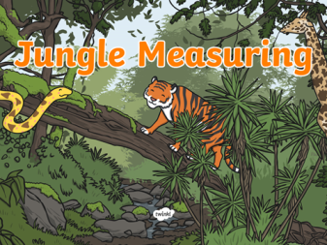  Complete ordering caterpillars sheet- cut out the caterpillars and order them from shortest to longest along the line of leaves. | Tuesday- Taller and Shorter Dice Game  Roll a dice. Collect the corresponding number of cubes and build a tower. Now build a tower that is taller and a tower that is shorter.  Roll the dice and have another go. What do you notice? Can you arrange your towers in order from shortest to tallest?  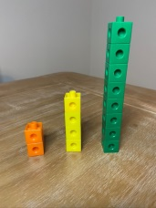
Wednesday- Longer and Shorter  Use playdough to make snakes of different lengths. You can line them up or use household objects to compare the lengths.  What do you notice?  Can you arrange your snakes in order from shortest to longest?  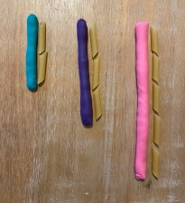 | Thursday- Footprint Measuring  Support your child to make a paper ‘footprint’. Can they find items around the house which are longer than their foot, shorter, about the same size? | Friday- Days of the Week  Miss Jewitt will post a video of herself reading Jasper’s Beanstalk today or you can click on the link below to listen to it  https://www.youtube.com/watch?v=Da6lxY_8jmU  Now have a go at putting the days of the week in order. You could use the sheet I have attached or write the days of the week on separate pieces of paper, mix them up and ask your child to put them in order.  You could also teach your family our ‘Days of the Week’ song which we sing in school.  https://www.youtube.com/watch?v=8GKmCQOy88Y

