Literacy challenges  Week beginning 29.6.20  This week our literacy challenges are based on the story, ‘Oliver’s Vegetables’’ by Vivian French.  You can begin by watching the story. We’ve suggested these follow up activities to consolidate a range of reading and writing skills previously taught in school.  https://www.youtube.com/watch?v=IhmqiEXe8dc  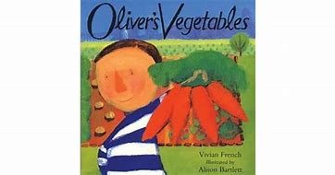 | Monday – Design and label your own garden  Which vegetables would you grow in your garden? Draw a plan of your garden and draw and label your vegetables.  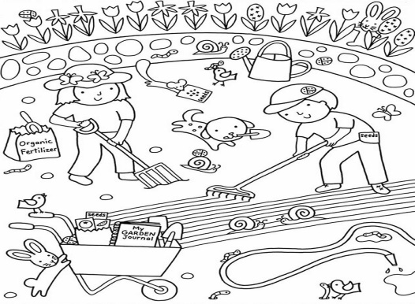 | Tricky Tuesday -writing  Can you write your name using a vegetable? Sometimes we have painted with vegetables in nursery and love how they all make different marks.  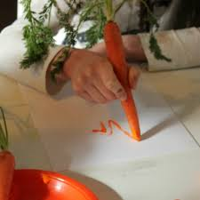  Which vegetable is most like a pencil? Can you write any other words?
Write it Wednesday  Can you think of a different fruit or vegetable for the letters of the alphabet?  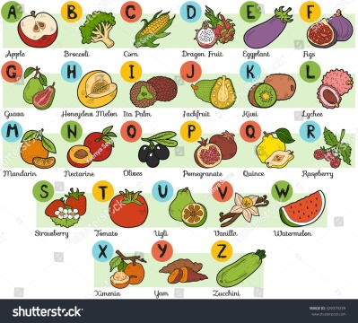 | Thursday – shopping fun  Read the letter from Oliver. Can you write a shopping list? Use your phonetic knowledge to help you.  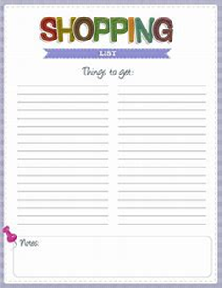 | Fact day Friday  Let’s find out about fruits and vegetables. Which is your favourite? Can you find out some information about it?  Where does it grow?  What shape is it?  What colour is it?  What does it taste like?  If you want to, you could make a poster or draw a picture to tell us about it.  