Nursery
Secondary Curriculum Driver: L (Literacy)

Intended outcome:
- Describes main story settings, events and principal characters
- Hears and says the initial sound in words
- Links sounds to letters, naming and sounding the letters of the alphabet
- Gives meaning to marks they make as they draw, write and paint
- Language and emerging writing in the role play castle.
Proposed learning opportunities:
- Provide a variety of fiction and non-fiction books relating to castles and traditional tales.
- Talk about the characters in stories we explore.
- Simple castle labelling
- Speed sounds activities linked to theme where possible
- Castle/ traditional tales writing frames, word cards and word mats
- Make up our own story books and castle fact files
- Writing medieval menus in the role play.
- Reading stories about history, castles, Kings, Queens, Knights and Dragons, (Zog, Zog and the Flying Doctors, The Queens Crown, The Paperbag Princess etc.)

Primary Curriculum Driver: UW (Understanding of the World)

Intended outcome:
- To make comments and ask questions about aspects of their familiar world, e.g. ranges of different buildings.
- To talk about some of the things they have observed or have prior knowledge of.
- To begin to talk about why things happen or how things work.
Proposed learning opportunities:
- Explore a range of castles through history and compare them to buildings in our local area, e.g. shops, Churches etc.
- To look at the features of castles and find out why they were built that way. Look at castles in storybooks.
- To talk about features of castles they would use in their own designs. To support children to design and make their own simple castles.
Curriculum Information
Summer 1
Long, Long Ago:
Castles, Traditional Tales
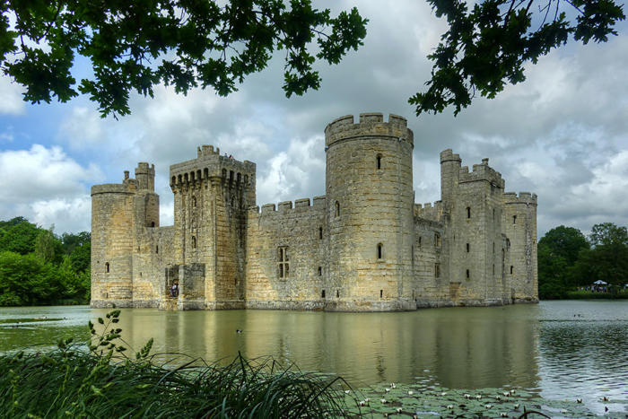
Expressive Arts and Design:
Proposed Opportunities:
- Making castles and parts of the castle
- Designing own castles and fictional chracters, e.g. giants etc.
- Designing costumes and settings.

Mathematical Development:
Proposed learning opportunities:

- Beginning to explore time, e.g. sequencing parts of the day
- Continue to explore 2D shapes
- Using familiar shapes/ common objects to create and recreate patterns and build models.
- Begin to use simple language relating to money.

Communication and Language:
Proposed learning opportunities:

- Role play in the castle
- Castle/ traditional tales story stones
- Traditional songs and rhymes
- Fairy tale/ fantasy world imaginary play
- Fairy tale listening and attention activities
*The storytelling chair to share oral stories.

Physical Development:
Proposed opportunities:
- Using the new balance bikes safely, mounting, dismounting, and negotiating around obstacles.
- Commando Joes
- Athletics and team games.

Personal, Social, Emotional:
Proposed opportunities:
- Teamwork challenges, supported through the Commando Joe programme.
- Parachute games
- Sharing and taking turns
- Taking on different roles in the role play area.

