Literacy challenges  Week beginning 15.6.20  This week our literacy challenges are based on the story, ‘Princess Mirror Belle and the Dragon Pox’ by Julia Donaldson.  You can begin by listening to the story. We’ve suggested these follow up activities to consolidate a range of reading and writing skills previously taught in school.  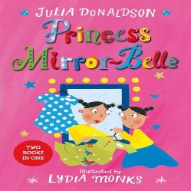  https://www.youtube.com/watch?v=LAFaJfcqqt4&t=1s | Monday – What does your mirror self look like?  Read or listen to the story. Can you look in to a mirror? What do you see? Can you draw yourself and your mirror self? It could be your Princess self or your Prince self. Maybe you could label the parts of your face, using your phonics to help you.  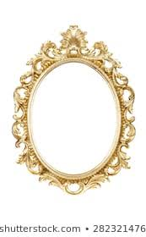 | Tuesday – Wizarding words! Join phonics and literacy together  Mirror Belle likes to make up her own cure for dragon pox, can you make one up too?  Using the letters we have learned can you pick 5 and think of ingredients for a magical cure that begin with those sounds?  E.g. m could be marshmallows, p could be purple potatoes.  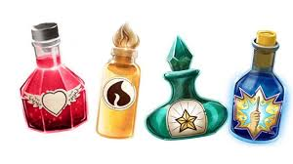
Write it Wednesday  ‘If I had a mirror self we could…’ writing activity.  Using the writing sheet, think carefully about what you would do if you had your own mirror self, just like Mirror Belle. What would you do together?  Can you write (mark make) your ideas? Maybe you could be even more brilliant and sound out the letters you can hear and try to write them?  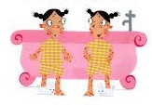 | Thursday – Break the rules for the day  Mirror Belle tells Ellen that she is allowed to splash water all over the bathroom floor in her palace. Can you think of some rules that you could break? (Safe ones of course.)  I can think of a couple to start  Always have lots of chocolate before dinner.  Never go to bed until after midnight!  Put lots of glitter and slime in the bath. | Friday – Wonderful imagination  Imagine you lived in a castle like Princess Mirror Belle. What kind of kingdom would it be? Would it be high up a mountain or in the middle of a grassy field? Would you have a moat or a ferocious dragon to protect you? What kind of rooms would you have in your castle, an enormous soft play room? Secret tunnels to go on adventures in?  Can you draw your own castle with all of the things you would like it to have.  