Reception

**Secondary Curriculum Driver: CL (Communication and Language)**

**Intended outcome:**

Children can listen to stories with increasing attention and recall.

Listens and responds to ideas expressed by others in conversation or discussion

Children are beginning to understand ‘why’ and ‘how’ questions.

Uses language to imagine and recreate roles and experiences in play situations.

Introduces a storyline or narrative into their play.

**Proposed learning opportunities:**

Begin to learn about our local environment of Corbridge, and ask questions about the area.

Engage in imaginative play, recreating familiar ‘home life’ scenarios.

Extend vocabulary relating to learning our 5 senses.

**Primary Curriculum Driver: PSED (Personal, Social and Emotional Development)**

**Intended outcome:**

Children can play in a group, extending and elaborating play ideas, e.g. building up a role-play activity with other children.

Children can explain their own knowledge and understanding, and asks appropriate questions of others.

Children are able to listen to others’ ideas and take in to account what other people say.

Children are confident to talk to others when playing, and will communicate freely about own home and community.

Children can describe self in positive terms and talk about abilities.

**Proposed learning opportunities:**

Circle time exploring ‘All About Me,’ finding out about homes, families, interests etc.

Follow new rules and routines

Talk about their skills during Special Person time.

Autumn 1  
All About Me

[](https://www.google.co.uk/url?sa=i&rct=j&q=&esrc=s&source=images&cd=&cad=rja&uact=8&ved=0ahUKEwiGmKeD6YnWAhVCuRQKHUtKD-sQjRwIBw&url=https://www.education.com/slideshow/not-playing-well-with-others/&psig=AFQjCNH6B9KMXurzq9r1uFha1cnHKQCnGg&ust=1504555668635893)

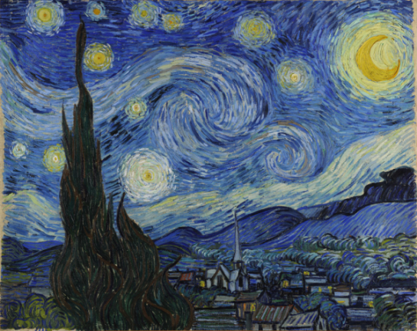

**Literacy:**

**Proposed learning opportunities:**

Recap phonemes taught so far through daily phonics sessions

Focus on tricky words – I, go, into, to the, no

Recognise the words in different contexts – play word splat, missing word etc

Form letters of their first name correctly

Make up their own stories using picture cards and books

Make a book about themselves

**Expressive Arts and Design:**

**Proposed opportunities:**

Develop story telling language through imaginative role play

Self-portraits-mark making and colour selection

Learn a range of songs all about me/ ourselves

**Mathematic Development:**

**Proposed learning opportunities:**

Count how many children are in school each day

Count how many boys and girls and discuss which is the biggest group

Count votes using our class voting station to choose a book at the end of the day

Learn a range of counting songs

Weigh out simple ingredients to bake bread

Order numbers on a washing line (0-9)

Work in groups to build models to match their description (longest, shortest, widest)

Complete repeating patterns with a range of resources

Use shape names square, oblong, rectangle and circle.

**Understanding the World:**

**Proposed opportunities:**

Read the Creation story

Ask questions about God and the world Christian’s believe he created

Observe seasonal changes

Harvest activities: making toast, and vegetable soup

To begin to learn about computers and their functions (mouse and keyboard).

**Physical Development:**

**Proposed opportunities:**

Mark out a track and navigate it using the bikes and scooters

Put own coats and wellies on

Change independently for PE

Team games developing a range of skills

Try new fruit and vegetables at snack and lunch times.