Things to do outdoors!

Dear parents, carers of nursery children

We continue to miss you every day but we enjoy hearing about the things you have been doing to stay safe with your families. There will be so much to talk about when we finally meet up again in school!
Although the weather is cold we love to wrap up warm and explore outdoors…….. so we thought you might like to try some of the outdoor activities and ideas we have suggested.
We sometimes call these secret learning activities because while you are playing and having fun outside you are also learning so many important skills!
Have fun!

1. Go on a Winter Scavenger Hunt
Scavenger hunts encourage children to use and develop their observation skills. When they are hunting for treasures they pay more attention to their surroundings and notice things they may have missed otherwise. So they are a wonderful way to help youngsters increase their awareness of the environment.
Head to the outdoors and look out for...
- berries
- Frozen puddle
- Bird in a tree
- Pine tree
- Snowy animal footprints
- Fallen brown leaf
- Feather
- Icicle
- Aeroplane in the sky
- A person wearing a scarf
- Squirrel
- A red car

2. Tiny Treasure Hunt
You’ll need to keep your eyes peeled for this activity. Hunt for really small things you can fit into a matchbox. Collect little leaves, blades of grass, small snail shells, tiny twigs, feathers and pebbles. Turn it into a competition with your family – who can fit the most items inside their box? You can take a magnifying glass on your scavenger hunt to help children to investigate their finds. Can they see intricate patterns, subtle colour changes and interesting textures?
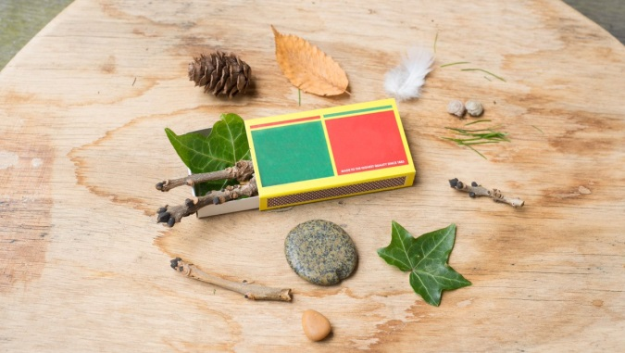

3. Make Natural Art
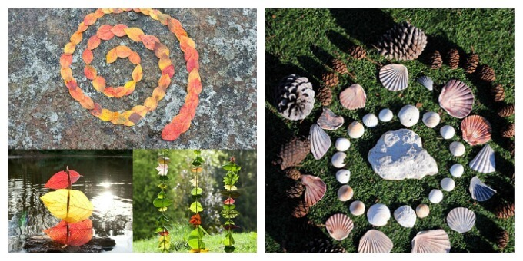
Put pencils and crayons to one side and look for natural art materials instead. Collect fallen leaves, pebbles and sticks and use them to make a picture or sculpture.
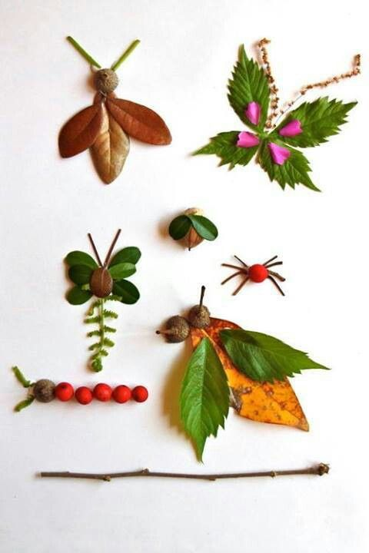

Find out about Richard Shilling who is a land artist based in Northern England who encourages children to get outside to see and create art in nature. https://www.richardshilling.co.uk/
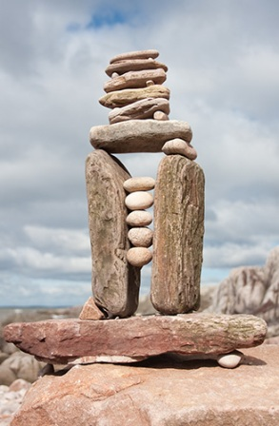
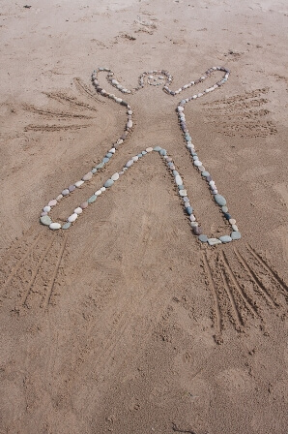
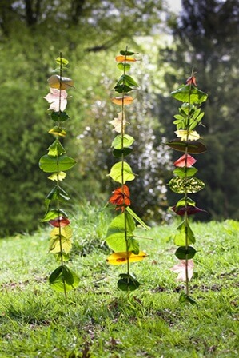
Andy Goldsworthy is also an artist who uses natural materials. What ideas do you have for making a nature sculpture or picture? Send us a photograph or your idea, we would love to see them.

4. Blow Bubbles
Is it really cold? Then try blowing bubbles outside to see how frost patterns form on them. Blow the bubbles next to a cold surface so that they don’t break in the air, and use a Bubble Wand to catch them!

5. Run an Obstacle Course
Keep the children moving! Let the children design their own obstacle course to encourage physical activity and use of all gross motor skills – even throughout the colder months.

6. Go on a Treasure Hunt
Follow the star! Create an exciting treasure hunt where the children follow the star until they discover a yummy treat at the end. Each star will contain a physical activity (for example, 10 star jumps) and a clue to find the next star.

7. Build a Snowman
Is it snowy outside? Then let’s get wrapped up warm and go make frosty the snowman!
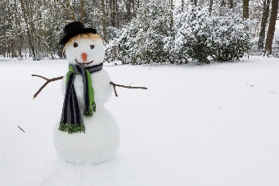

8. Chalk fun
Using chalk draw a train track outside for a train to travel along. You could number your track 1-20- what number will your train stop at. You could also use chalk to draw story pictures, to practise your tricky words or to draw hopscotch.
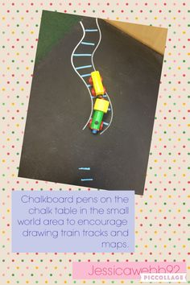

9. Counting challenges
You will need a stopwatch or a mobile phone. Can you do some timed challenges? Ask a grown up to use the timer to measure how long it takes you to:
10 star jumps
Run around the garden
8 bounces on the trampoline
Write your name 3 times with chalk
Can you think of your own timed challenges? Can you beat your time?
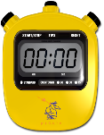
This Photo by Unknown Author is licensed under CC BY-SA

10. Ideas on how to include maths learning on a walk
Measurement Language
Cars, flowers, leaves and even houses are great for talking about size. As you walk along you could ask which is the biggest of 3 objects. You could look at the leaves on the ground and sort them into size order from biggest to smallest or smallest to biggest. During a walk is also a good time to introduce the language of fast, slow, tall, short.
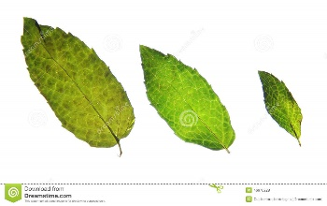
Shapes Road signs, paving slabs, windows and manhole covers/drains are different shapes. Start off spotting squares, circles and triangles, and then add in rectangles and ovals.
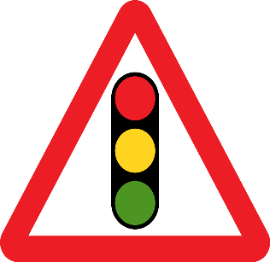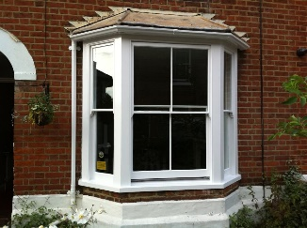
This Photo by Unknown Author is licensed under CC BY-SA

Counting
There are so many counting opportunities when you are out for a walk. How many houses are on your street? How many trees are along the road? How many people are in the park? How many will there be if I add the number of slides and the number of swings together? How many steps from your house to Grandma’s house? You could introduce estimation by asking “Can you estimate (have a good guess) how many people are in the park? And then carefully count to see how close you were to your estimate.

Number Recognition
Ask the questions "What numbers can you see on the doors?", “can you see any numbers on road signs?” You could take a notebook on your walk and write down all the numbers you find. We work on numbers up to 20 in school.
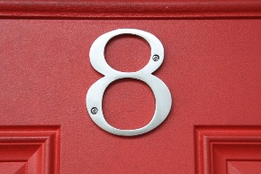

I have also attached some links for online resources which can be used to keep your children active in the house:

Cosmic Yoga- fun story themed yoga videos aimed at children: https://www.youtube.com/user/CosmicKidsYoga
Change 4 Life- A variety of shake up games to keep children active: https://www.nhs.uk/10-minute-shakeup/shake-ups
Disney Dance along songs: Aimed at ages 5 to 8, a variety of dance along videos with ‘This Girl Can’:
https://www.thisgirlcan.co.uk/activitie s/disney-workouts/
Just Dance: A variety of songs for children to dance to by copying the movements
https://www.youtube.com/user/justdancegame
Go Noodle: A variety of movement videos for kids
https://www.gonoodle.com/

