Horrid Henry and Moody Margaret
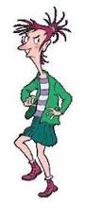
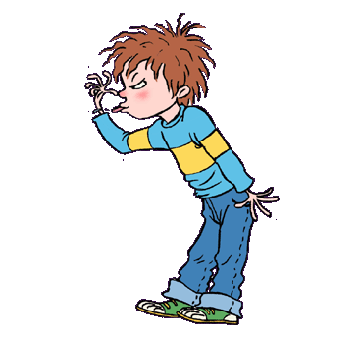
“I’m Captain Hook!”
“No, I’m Captain Hook!”
“I’m Captain Hook,” said Horrid Henry.
“I’m Captain Hook” said Moody Margaret.
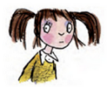
They glared at each other. “It’s my hook,” said Moody Margaret.
Moody Margaret lived next door. She did not like Horrid Henry, and Horrid Henry did not like her. But when Rude Ralph was busy, Clever Clare had flu, and Sour Susan was her enemy, Margaret would quickly jump over the wall to play with Henry.
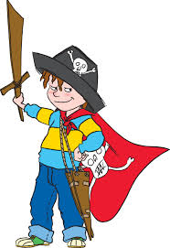
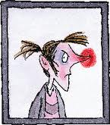
“Actually, it’s my turn to be Hook now,” said Perfect Peter. “I’ve been the prisoner for such a long time.”
“Prisoner, be quiet! Said Henry.
“Prisoner, walk the plank!” said Margaret.
“But I’ve walked fourteen times already,” said Peter. “Please can I be Hook now?”
“No, by thunder!” said Moody Margaret. “Now out of my way, worm!” And she swashbuckled across the deck, madly waving her hook and clutching her shiny sword and dagger.
Margaret had eye patches and skulls and crossbones and plumed hats and cutlasses and sabres and snickersnees.
Henry had a stick. This was why Henry played with Margaret. But Henry had to do terrible things before playing with Margaret’s amazing swords. Sometimes he had to play ‘Mums and Dads’ with her. Worst of all (please don’t tell anyone), sometimes he had to be the silly baby.
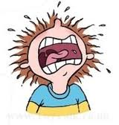
Henry never knew what Margaret would do. When he put a spider on her arm, Margaret laughed. When he pulled her hair, Margaret pulled his harder. When Henry screamed, Margaret would scream louder. Or she would sing. Or pretend not to hear. Sometimes Margaret was fun. But most of the time she was a moody old grouch.

Friday 26th June – Can you answer questions about a text?
Can you infer meaning?

Questions about Horrid Henry and Moody Margaret
- Who did Moody Margaret and Horrid Henry both want to be?
__________________________________________________________
__________________________________________________________
- Moody Margaret only played with Horrid Henry when who else was busy?
__________________________________________________________
____________________________________________________________________________________________________________________
__________________________________________________________
- What was Perfect Peter pretending to be?
__________________________________________________________
__________________________________________________________
- What had Perfect Peter done 14 times?
__________________________________________________________
__________________________________________________________
- What do you think swashbuckled means?
__________________________________________________________
__________________________________________________________
__________________________________________________________
- What did Moody Margaret have that Horrid Henry did not have?
_________________________________________________________
__________________________________________________________
__________________________________________________________
__________________________________________________________

- What terrible things did Horrid Henry have to do when he played with Moody Margaret?
__________________________________________________________
__________________________________________________________
__________________________________________________________
__________________________________________________________
- What did Moody Margaret do when Henry put a spider on her arm?
__________________________________________________________
__________________________________________________________
- What two things did Moody Margaret do when Henry screamed?
__________________________________________________________
__________________________________________________________
__________________________________________________________
__________________________________________________________
- Underline the adjective in this sentence:
“No, by thunder!” said Moody Margaret. “Now out of my way, worm!” And she swashbuckled across the deck, waving hook and clutching her sword and dagger.

- Find two adverbs that appear in the text.
_____________________________
_____________________________
- Read the following sentence again:
“It’s my hook,” said Moody Margaret.
Why do you think my is in bold?
__________________________________________________________
__________________________________________________________

